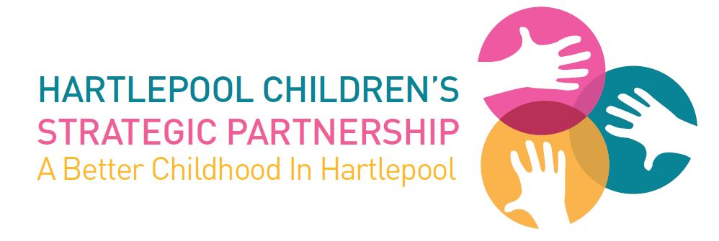
BRAND GUIDELINES 2018

The importance of a strong brand

Research shows that organisations with a strong brand receive higher levels of satisfaction from customers. A strong brand also enhances their credibility.

Using the logo correctly

There are two logo options to choose from depending on the application - the horizontal logo and the vertical logo. The choice of logo should depend on which will give the most prominence for a given application.

Whilst sometimes the vertical logo will fit an area better, a lot of marketing applications will require the horizontal version due to space restrictions and layout considerations.

Horizontal logo: Vertical logo:

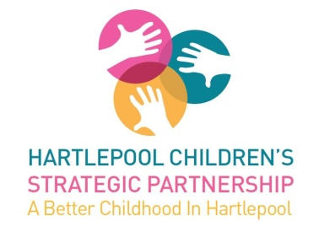

The logos can be downloaded by at www.hartlepool.gov.uk/hcsp-brand-toolkit

Partnership colours

The Partnership logo consists of three colours. You will find the RGB colour values below:

R9, G132, B150

R239, G89, B161

R251, G180, B76

Font usage

Using a consistent typeface for all documents is vital to maintaining the consistent and professional image of the Partnership.

Arial should be used as this is a system typeface on all Windows, Linux, and Apple Macs which means a consistent look and feel can be maintained in-house.

Arial is a very legible and clean typeface and we advise a minimum font size of 10 – 12 points.

Letterheads

In the interests of efficiency, we have a standard letterhead which incorporates the Partnership logo.

This letterhead can be downloaded at www.hartlepool.gov.uk/hcsp-brand-toolkit

PowerPoint

A template PowerPoint presentation can be downloaded from www.hartlepool.gov.uk/hcsp-brand-toolkit

For any questions regarding these brand guidelines please contact Hartlepool Borough Council’s Communications and Marketing Team on (01429) 523578 or communications@hartlepool.gov.uk

