Part 2
Hartlepool Borough Council
(Licence Under Section 184 of the Highways Act 1980)
Advanced Notice of Installation of Vehicle Crossing

Applicant/Contractors Signature:
Date:
Name of Contractor Undertaking Works:
Address:

Postcode:
Telephone Number:
Public Liability Insurance Details
Policy Number:
Start Date:
End Date:
A copy of your insurance documents should be sent to Hartlepool Borough Council on an Annual Basis.
Details of Proposed Works:
Property Owners Name:
Address of Property:

Post Code:
Telephone Number:
Is this application for a new vehicle crossing or an extended vehicle crossing? | New vehicle crossing/Extended vehicle crossing
Proposed Start Date:
Proposed End Date:
Are there any Traffic Management Considerations that need to be considered?  (If works on main road please contact Peter Nixon. Tel: 523244) | YES/NO  If yes please provide further details
Flagged or Tarmac Footway?
Additional Comments:

Is crossing for use of cars and light vehicles (up to 3.5T) only? | YES / NO
Is planning permission required? *Planning Permission is generally required on classified roads only | YES / NO / NOT SURE  If YES, please enclose a copy of the planning approval document(s).
Is the gradient of the proposed crossing acceptable? | YES / NO / NOT SURE
Photographs - Please provide a photograph of the proposed site wherever possible.

Drawing of Proposed Vehicle Crossing Location

Please ensure that accurate measurements are shown on the drawing. Also include any street furniture features such as trees, lighting columns, utility covers etc.

Minimum private drive/hard standing size is 5 metres x 2.5 metres wide.

A standard vehicle crossing will normally be 2.7m wide as shown here i.e. 3 dropped kerbs and 2 transition (sloping) kerbs (one either side), making 5 kerbs with a total length of 4.5 metres. If for any reason you require anything different, please state what and why.

NOTE: Drawings by hand are acceptable, and photos welcomed. An example and a space to draw the proposed crossing are shown below.

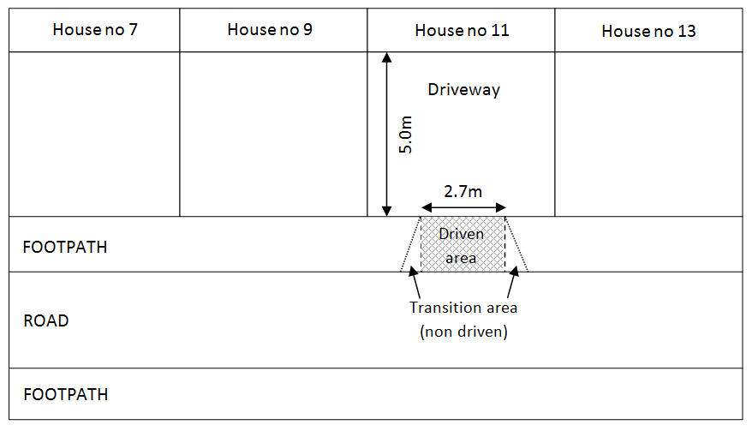
Please draw the location of the proposed vehicle crossing in the box below (example above)

Please complete this form and email it to: highways@hartlepool.gov.uk.

Enquiries to Ralph Young on Tel 01429 284141 or Sally Eyre on 01429 523240.

Vehicle Crossing Contractors Standard Conditions

- The new vehicle crossing or alteration to existing vehicle crossing has to be applied for, and agreed by the Council prior to construction. This is the
Resident’s/ business owner’s responsibility, unless the contractor assists with or completes the application form on their behalf.

- Contractors shall have a current policy of insurance covering Public Liability in the sum of at least £2 million.

- Contractors will indemnify the Highway Authority in respect of all claims made as a result of the carrying out of the works.

- Contractors will maintain the work to the satisfaction of the Highway Authority for a period of 1 year commencing from the notification of completion of the works.

- Payment in advance of licence and inspection fees is currently £145.00 (VAT Exempt).

- The works will be completed in accordance with the Highway Authority Specification, industrial and domestic crossings

- Contractors shall issue a 7 day (considerations may be given for restrictive locations)- Advance Notice of Works Including Responses and ensure any skips etc. on the public highway are licensed.

- Construction will be continuous through to completion without undue delay and any excavations must be properly signed in accordance with Chapter 8 of the Traffic Signs manual.

- Materials used are to be as existing, unless otherwise agreed with the Council prior to the commencement of works.

- If there is any breach of the above conditions, the Highway Authority reserves the right to complete the works and re-charge the undersigned any costs associated therewith.

- Sub-standard workmanship/ operations may result in removal from the Accredited Contractors List.

- All work shall be carried out between the hours of 08:30hrs and 18:00hrs.

- Commencement of works should not be undertaken until a permit has been raised by Hartlepool Borough Council and full payment has been made.

