Hartlepool Borough Council Special Free School

Seeking proposals to establish a Special Free School
Hartlepool Borough Council
February 2019 updated July 2019
SECTION ONE: OVERVIEW

- Summary

The Department for Education (DfE) is working collaboratively with selected Local Authorities to establish new schools that fit within the local authorities’ strategies for children and young people with special educational needs and disabilities (SEND) and those requiring alternative provision. This opportunity is intended to identify and meet untapped demand for special and alternative provision free schools as a supplement to LAs’ existing resources. If a strong proposal is received by a trust that both the Local Authority and the Secretary of State wish to take forward, DfE will provide capital funding and start-up grants subject to value for money assessments.

This document sets out the key information regarding the school that Hartlepool Borough Council will be establishing alongside DfE. Trusts should use the information within this document, alongside the engagement events, to determine whether they would like to apply to open the school, and to base their application on.

- Key dates

24 July 2018 | Special and AP free schools wave is launched – the guidance and criteria for local authorities seeking to establish new special or alternative provision free schools is published.
11 March 2019 | Announcement of successful LA bids. Competitions in successful areas subsequently open.
20 May 2019 & 1 July 2019 | Sponsor Engagement Events.
30 September 2019 | Deadline for proposers to submit applications in successful areas.
September to December 2019 | Hartlepool Borough Council and DfE to evaluate submitted applications and interview trusts. Secretary of State’s decision on successful proposer groups.
Early 2020 | Approved applications announced.

- Contact details and further information

If you would like any further information or would like to discuss your application, please contact:

Name: Kelly Armstrong
Job title: Head of Service, Children’s Commissioning
Email: Kelly.Armstrong@hartlepool.gov.uk
Tel: 01429 523043

If you would like any further information or would like to discuss the site, please contact:

Name: Philip Timmins
Job title: Principal Estates Surveyor
Email: Philip.Timmins@hartlepool.gov.uk
Tel: (01429) 523228

Please find below the contact details of the Regional Schools Commissioner: [Include RSC details for that region]

RSC: Jan Renou
RSC’s office: North of England
Email: rsc.north@education.gov.uk

- Hartlepool Borough Council Context and Planning

Please include here details of why the local authority is running this competition and requires this school. Should this be a joint bid, please explain how the local authorities will work together and how other local authorities are involved in commissioning places.
Hartlepool is a small town in the North East with an overall population of 93,000 young people aged 5-18 account for 16,000 of the population.

In 2015, the Indices of Multiple Deprivation indicated that Hartlepool was ranked 17th most deprived out of 149 top tier local authorities in England. Estimated level of child poverty in Hartlepool as classified by the government is 32%. Increased levels of child poverty directly lead to:

- Increased levels of vulnerability and need
- Increased demand for help and support services across whole system
- Low resilience
- Health inequalities and significant life expectancy gap
- Low levels of ambition, aspiration, confidence and self belief

Hartlepool has the second highest death rate from drug misuse in the North East Region. Substance misuse is a major factor in child neglect, children’s emotional wellbeing, domestic abuse, anti social behaviour and children being taken into care.

In a small town the above factors all impact on the emotional health and wellbeing of children and young people in Hartlepool.

There are higher numbers of young people with SEND in the North East (27.2%) than nationally (18.2%) and high numbers of pupils with SEMH in the North East (21.8%) than nationally (13%). There are significant mental health needs as well as a growing population of pupils who suffer from attachment disorders and who have highly complex family issues which impact negatively on their behaviour attendance and outcomes. The Children’s Strategic Partnership is currently focusing on raising awareness of Adverse Children’s Experiences. It is evident from the reviews of cases we have undertaken that a large proportion of our children with SEMH issues have had Adverse Childhood Experiences.

The vision of Hartlepool Children’s Strategic Partnership is to:

“To enable all children and families in Hartlepool to have opportunities to make the most of their life chances and be supported to be safe in their homes and communities.”

Hartlepool has two special schools, a primary and secondary through to post 16. Both schools cater for a wide and diverse range of needs, the current make up includes ASD, PMLD, SPLD, MLD and a small number of SEMH young people whose levels of learning are very low. Many young people with SEMH do not meet entry criteria in relation to their levels of learning being too high and a suitable curriculum is not available within an already full school.
The PRU in Hartlepool is over capacity, a number of pupils remain in alternative provision for entire key stages. Some reasons are: mainstream settings don’t have capacity/skills/resources to provide specialist intervention required; the nature of complex needs prevents successful reintegration back or longer term intensive intervention is required prior to reengagement.

There are currently 30 young people with a presenting need of SEMH accessing out of area provision. The majority of pupils are transported out of borough, meaning pupils travel for over 40-50 minutes to and from school. This includes long distances on motorways and presents considerable safety concerns and considerable expense, currently in excess of £200k. Currently 3 of the ISP providers used Require Improvement and 3 are not yet inspected.

If predicted growth continues by 2026 there will be in excess of 60 young people who will be placed outside of the town. These young people are often our most vulnerable members of society, this causes distress and increased anxiety for both the young person and parent/carer. Links to Hartlepool’s local community are lacking and result in parents feeling isolated. Transition back to the area at a key stage change is often turbulent and unsuccessful.

The development of a school in Hartlepool providing SEMH provision meets within the vision of a systemic graduated response. It will be one part of the system that offers key stage 2-5 focussing on specialist therapeutic interventions, support for the most challenging of behaviours, high quality in/outreach support to schools to allow for re integration whenever possible as part of Hartlepool’s SEMH graduated response. The school will complement the existing offer, address the gaps in the current offer of provision and provide outstanding education and support for children and their families.

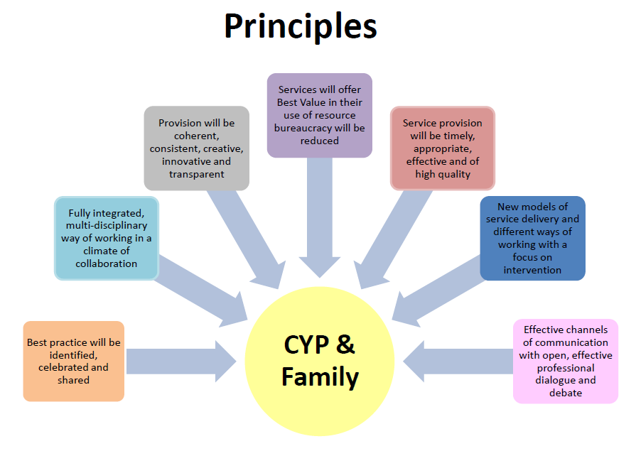
The school would add value to the existing SEMH graduated response (see Appendix A) by the provision of;
- Multi disciplinary assessment places for young people who require a high level intervention as directed by the LA
- Localised delivery of coaching/training to include:
  - attachment awareness
  - behaviour management
  - solutions focused interventions
  - Family support
- A long term specialised and targeted placement for young people who require specialist provision as outlined in their EHC Plan.

In addition the school will work in partnership with other teams to ensure a child centred approach addressing all the child’s needs which includes social and environmental. The school will work closely with other teams across the system including: Integrated Early Help teams, Social Care Teams, and health teams.

These will also be a base for Mental Health Support Teams for Schools (MHST) if the Trailblazer bid across the Hartlepool and Stockton Trust (HAST) is successful (17/10/2018), so that this service is more accessible to schools and families.

The expertise developed within the school will allow us to build capacity within our mainstream settings, so that a greater number of young people with SEMH are able to remain in these settings and achieve good or outstanding outcomes measured as below: -

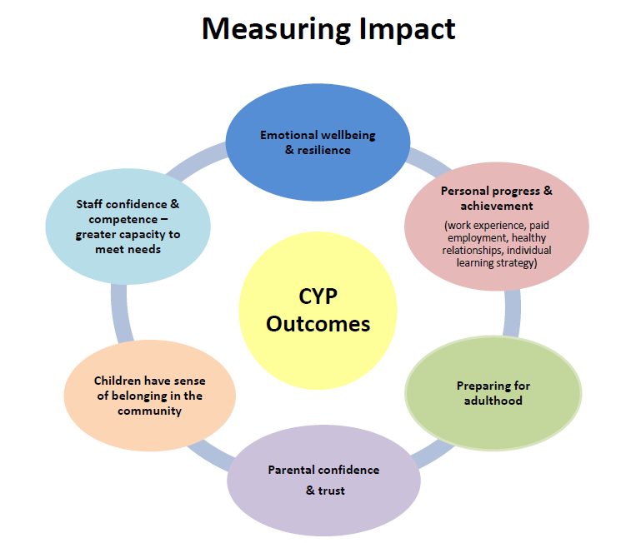

Additional information
The SEMH free school will form part of the graduated response to SEMH which has been adopted by all partners across Hartlepool. Entry to the free school will not be via any one feeder school, and instead will sit with the LA and the SEMH Panel which has representation from mainstream schools, SEMH Additionally Resourced Provision (ARP), educational psychology, social care, early help and CAMHS. Young people are brought to panel for discussion by their home school who complete paperwork in advance and provide detailed information to support the application. The role of the panel is to review each young person and put in place recommendations for funding to access support in mainstream, outreach support, or entry to the SEMH Additionally Resourced Provision (ARP) for period of assessment.

If a placement for specialist provision is required or made as a recommendation from SEMH Panel or in the EHC plan, for SEMH provision which sits outside of the current graduated response offer, the young person’s placement will be discussed at SEND Commissioned Placement panel. This panel is chaired by the Assistant Director of Joint Commissioning at the LA and ratifies and sources all external placements outside of the LA’s current offer, the panel is multi agency, with representation from LA, CCG and TEWV. Funding splits across agencies are also agreed at this panel and placements are continually reviewed and discussed to ensure they meet need.

The free school will provide the specialist provision element of the graduated response which is currently lacking in Hartlepool, it is hoped this will prevent young people from having to access high cost, sometimes poor quality SEMH day or residential provision located outside of the town. This will ensure they can access their learning and specialist services within their own community, creating a greater sense of belonging for both the young person and their family. This was highlighted as the most important element for families in a recent consultation carried out with parents/carers about Hartlepool’s current offer of special education provision.

Extract from consultation from parents in 2018 as part of a review of SEMH/ASD provision across the town.

‘parents and carers want more localised provision for their children, their children to educated and be part of the local community, greater access to therapeutic support services and one stop local access point.’

Transition to the provision for each young person will be person centred and focus on meeting their needs in the best way possible. When appropriate after a period of assessment or intervention a young person may step down into an ARP or mainstream provision with support, this would be facilitated by intensive in-reach support to the relevant placement by the free school to ensure successful re integration, by offering the right support at the right time.

The SEMH Graduated Response is included as Appendix A.
SECTION TWO: THE SCHOOL

The tables below list key details of the school proposed. Your application must be for a school that has these key characteristics. Please note you only need to complete the relevant table depending on the type of school.

Type of school | Special
Area of SEN provided for (please detail designation alongside additional information known about the cohort’s needs and abilities) | SEMH including other secondary needs including but not necessarily limited to Speech and Language and Autism
Which local authorities are committed to commissioning places? | Hartlepool Borough Council
How many places have been commissioned and by which local authority? | School size: 50  46 across KS 2,3 & 4  4 KS5 places  5 of the above places will be used for assessment
Per-pupil revenue funding the local authority would expect to pay (if a range of rates, please explain and detail the rates per pupil, including estimates for how many of the cohort will be in each band) | £10k per place plus a top up rate per pupil based on the current banding system used in Hartlepool which allows a young person’s individual needs to be met. Top ups will be as follows:  6i £14,000  6ii £19,000  7 £24,000  It is anticipated the majority of children will be split between the 6i and 6ii bands, where there is a higher presenting need some young people may start at a band 7 for a period of settlement. Young people may fluctuate between the bandings throughout their education depending on their presenting needs.  Assessment places will be funded at £12/14k per placement, based on an FTE equivalent basis throughout the year. Young people may access a place for between 6 – 12 weeks after which a review will take place.
Age range | KS2-4, increasing to KS5 in year 3 of the development of the school (7-18yrs)
Gender (Boys/Girls/Co-educational) | Co-educational
Total number of proposed full time equivalent places (once school is at full capacity – this should include 16-19 places but not nursery) | 50 which include 5 rotating assessment places
Type of placements offered (e.g. full time, short term, part time) | Full time & assessment dual role with home school
Number of nursery places, if applicable | None
Number of 16-19 places, if applicable | 4 – in year 3 for progression from key stage 4.
Any planned outreach, training and/or reintegration support (including details of funding that will be made available to support the school with this) | The school will offer dedicated outreach role to improve the skills of the workforce, build capacity and share expertise in Schools/PRU by offering, but not limited to the following;  - Workforce Development Programme to include coaching and training for school on: - attachment awareness, behaviour management, team teach, solutions focused interventions etc  - Enhanced transition support to young people entering or existing the school particularly at key stages  - Outreach support via observation in schools if requested by LA (subject to school availability of staff), telephone etc  - Sharing best practice at SENDCO forums  - Family support  - Support to SEMH Oversight Group on strategies to embed inclusive quality first teaching for young people with SEMH in schools  - Support to SEMH Panel on resources which could be offered to support individual pupils submitted to panel for support  The young person will remain on role of the home school (unless it is names in the EHC Plan). Reviews and progress will take place as per the home school agreement. The home school and any specialist services accessed by the young person will remain a critical part of all review processes. When re integration is agreed the school will support the home school to ensure strategies for support are embedded and tested prior to reintegration starting.

The table below details the number of places that the local authority proposes for each year group at the point of opening until the school is full.

 | Year of opening | +1 | +2 | +3 | +4 | +5 | +6
Nursery | 0 | 0 | 0 | 0 | 0 | 0 | 0
Reception | 0 | 0 | 0 | 0 | 0 | 0 | 0
Key stage 1 (Y1-2) | 0 | 0 | 0 | 0 | 0 | 0 | 0
Key stage 2 (Y3-6) | 6 | 6 | 6 | 8 | 8 | 8 | 8
Key stage 3 (Y7-9) | 6 | 9 | 12 | 20 | 24 | 24 | 24
Key stage 4 (Y10-11) | 3 | 5 | 10 | 10 | 14 | 14 | 14
16-19: commissioner referred | 0 | 0 | 2 | 4 | 4 | 4 | 4
Totals | 15 | 20 | 30 | 42 | 50 | 50 | 50

SECTION THREE: RATIONALE AND CONTEXT FOR THE SCHOOL
This section describes the rationale and the context in which the new school will operate.

3A. Please include a brief description of the existing provision in your area, future expected growth in pupil numbers and how you expect places to be filled.
Hartlepool is a small town in the North East with an overall population of 93,000 young people aged 5-18 account for 16,000 of the population.

In 2015, the Indices of Multiple Deprivation indicated that Hartlepool was ranked 17th most deprived out of 149 top tier local authorities in England. Estimated level of child poverty in Hartlepool as classified by the government is 32%. Increased levels of child poverty directly lead to:

- Increased levels of vulnerability and need
- Increased demand for help and support services across whole system
- Low resilience
- Health inequalities and significant life expectancy gap
- Low levels of ambition, aspiration, confidence and self belief

Hartlepool has the second highest death rate from drug misuse in the North East Region. Substance misuse is a major factor in child neglect, children’s emotional wellbeing, domestic abuse, anti social behaviour and children being taken into care.

In a small town the above factors all impact on the emotional health and wellbeing of children and young people in Hartlepool.

Currently Hartlepool has two special schools, one secondary and one primary who offer places for young people with SEMH as their primary need who meet entry criteria in relation to learning. In addition to this Hartlepool is developing SEMH ARP provision at both primary and secondary phases of education. The ARP provision will work collaboratively with mainstream schools and the PRU to build capacity and resilience within mainstream provision. Children will access the ARP’s with a view to receiving an intensive package of support facilitating a return to their home school.
Children with EHCP’s who require specialist SEMH provision and are able to achieve within a mainstream curriculum currently have to travel out of the Borough. The majority of these children are of secondary school age but significant changes are starting to show within the primary sector. Children who travel to school daily can have a commute in excess of 40-50 minutes.
Consultations undertaken with parents and carers have shown that they would wholeheartedly support the development of specialist provision in Hartlepool. This would give opportunities for closer working relationships between home and school. In addition young people could develop strong relationships with the local community, post 16 providers and future employers. It is envisaged that any provision would work collaboratively with all existing education provision and partner agencies to give an holistic approach to meeting need.

Consultations undertaken with parents and carers have shown that they would wholeheartedly support the development of specialist provision in Hartlepool. This would give opportunities for closer working relationships between home and school. In addition young people could develop strong relationships with the local community, post 16 providers and future employers. It is envisaged that any provision would work collaboratively with all existing education provision and partner agencies to give an holistic approach to meeting need.
Hartlepool has no specialist provision for SEMH. During 2017/18 we consulted and developed an SEMH ARP provision at primary level to support our vision of a graduated response model, a secondary offer is being explored for 2019/20. Hartlepool has two special schools, neither or which are designated for SEMH, both schools are full. The current make up of children is ASD, PMLD, SPLD and MLD. Many children with SEMH do not meet entry criteria as their levels of learning are too high.

The PRU in Hartlepool is over capacity, a number of pupils remain in alternative provision for entire key stages. Some of the reasons include: mainstream settings don’t have capacity/skills/resources to provide specialist intervention required; the nature of complex needs prevents successful reintegration back or longer term intensive intervention is required prior to reengagement. Current numbers are:

- PEX - 19
- Managed Moves - 52
- Home Ed -44
- Home Tuition -1
- Fixed Term 2017/18 – 6463 incidents

In Hartlepool the number of fixed term exclusions have increased by 89% when compared to 2016/17 figures.

There are currently 30 children with a presenting need of SEMH accessing out of area provision. The majority of pupils are transported out of borough, meaning pupils travel for over 40-50 minutes to and from school, this includes long distances on motorways and presents considerable safety concerns and considerable expense, transport currently in excess of £200k. Day placements commissioned cater for a diverse range of SEMH needs, cost between £25-£78k each. Currently 3 of the ISP providers used ‘Require Improvement' and 3 not yet inspected.

If predicted growth continues by 2026 there will be in excess of 60 young people who will be placed outside of the town. These children are often our most vulnerable members of society, this causes distress and increased anxiety for both the child and parent/carer. Links to Hartlepool’s local community are lacking and result in parents feeling isolated. Transition back to the area after key stage 4 can be turbulent and unsuccessful

The high needs budget is significantly overspent, out of area placements remain the biggest budget pressure. Schools forum worked alongside the LA to review spend and implement a high needs funding review. Schools forum transferred £550k to the block 2017/18 and 2018/19.

Key Performance Indicators on Outcomes and Attainment
For Key Stage 2 attainment in 2018 young people across Hartlepool performed at 66.5% against a national average of 65%. When this dataset is ran by SEMH as a primary area of need identified by schools in census, achievement drops to 36.5% for this cohort of young people. This dataset is not wholly representative of the full SEMH cohort as it is dependent upon how schools record young people’s needs at point of census.
The LA is working with School Improvement and the SEMH Working Group to look at this area in more detail to gain a more accurate baseline in which to measure success and improve outcomes for our young people who have an EHC or who are SEN Support across the town. KPI’s around the new SEMH ARP provision are being built into commissioning agreements and will be reviewed via annual report and at annual monitoring visits. This will allow for accurate benchmarking and measure progress for young people at individual and cohort level at the point of entry/exit from the provision and when they return to home school at key points of assessment.
For Key stage 4 in 2018 young people across Hartlepool perform below the national average for all young people and for those identified as SEN Support.
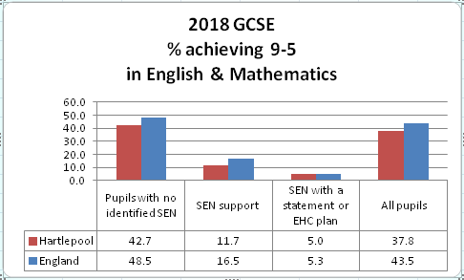
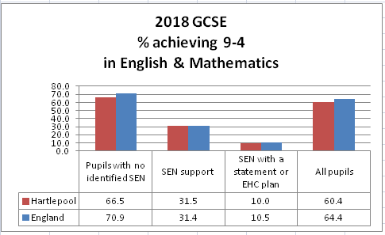

We envisage that the SEMH free school will provide young people with the opportunity to access their learning in a more supportive and appropriate environment with highly trained staff who can share their knowledge across the town through multi agency working and structured outreach and training to mainstream schools. The LA would propose to work with

We envisage that the SEMH free school will provide young people with the opportunity to access their learning in a more supportive and appropriate environment with highly trained staff who can share their knowledge across the town through multi agency working and structured outreach, support and training to mainstream schools. The LA would propose to work with the free school and SEMH Working Group to establish robust baselines and set KPI’s on the following areas. The KPI’s will be reflected in personalised support plans for each young person accessing the provision and aggregated to cohort level data to measure success for young people and via data collection, surveys and census information from mainstream schools.
KPI’s:
- Improved attendance
- Reduction in fixed term exclusions
- Increase in positive behaviour linked to personalised behaviour targets
- Improvements in working independently and as part of a group
- Increase in number of young people accessing relevant and meaningful work experience
- Young people are working towards preparing for adulthood which is demonstrated when appropriate in their personalised learning plan
- Enhanced individual key transition support to reduce move on placement breakdown measured by robust destination data
- Increase in the number of staff in mainstream schools supported by outreach work to increase their confidence in supporting young people with SEMH
- Increased attainment at Key Stage 2 for reading, writing and maths for young people with an EHC and the SEN support group
- Increased attainment for English and Maths at Key Stage 4 for young people with an EHC and the SEN support group
- School systems show clear evidence that they promote parent and carer contributions to maximise outcomes for pupils with SEND.
- School CPD programme includes specific and shared opportunities for parents and carers

The LA has consulted with partners to ensure that a new school would add to the whole system:

Schools Forum/SEMH Oversight Group:
Headteachers are committed to providing a breadth of provision for children with SEMH
which complements the current offer and promotes inclusion, meets needs and reduces current pressures on high needs block.

CCG:
Are supportive of a school which supports children’s emotional needs. This will link the Mental Health Trailblazer bid if successful. Outcome 17/10/18.

Parent Carer Forum:
A consultation with parents/carers has been undertaken, focusing on increasing provision across the town to prevent travelling out of area. Parents are supportive of increasing provision locally.

Independent Specialist School provider:
Cambian School has 18 places, and is at capacity, it is located on an industrial unit.
Hartlepool currently occupies a third of places.

3B Please also include details as to how these proposed new arrangements are likely to lead to improvements in the standard, quality and/or range of educational provision for children with special educational needs, and the outcomes for pupils, across the local authority and how you expect trusts to support this.
The LA is leading collaborative working across the system to improve the SEMH education offer for children and thus improving outcomes for children. The new school will be expected to be part of this collaborative system working jointly with education, health and care providers.

A young person who is allocated a place at the school will be via their EHC plan and this will be reviewed annually. There will be a number of assessment places. In these assessment cases the child will stay on the role of their home school and there will be a home school agreement. This will be reviewed as agreed in the child’s individual plan. When appropriate a re-integration package will be planned back to the home school. In cases where the assessment is recommending a different provision a transition plan will be put in place.

The school will set individual outcomes for children linked to the EHC/Co-ordinated Support Plan and IEP agreed in collaboration with home school if appropriate to ensure for the purposes of re integration the home school takes ownership of meeting needs of the young persons. The outcomes set will be SMART, allowing for meaningful progress at an individual level to be demonstrated. Significant work has been undertaken across the partnership to develop an outcomes framework for the progress of our children to be individually monitored. It is expected that the SEMH school will support the ongoing development of this work and also use this approach to measure progress for their children.

The school will offer 2 vocational post 16 pathways in its third year for young people not yet ready to transition into mainstream FE. This will prevent young people becoming NEET and allow them to gain essential skills in preparing for adulthood, including;

- meaningful work experience
- employability skills
- independent living
- transport training
- healthy life and relationships

The LA has a partnership with Public Health England to deliver Internships and be part of the collaborative. The LA has excellent relationships with Further Education sector, the school will work alongside the FE College to enhance the post 16 offer.

The new school will be part the SEMH graduated response offer across the town, see Appendix A. As well as dual role assessment places a number of children who require longer term specialist intervention will be accommodated in the new setting which will be named in their EHC plan. This will benefit mainstream and special schools who currently hold children for longer than necessary whilst an ISP placement is sourced, preventing other children from accessing provision. This delay results in excessive demands being placed on staff and children, impacting upon emotional wellbeing. There is already significant expertise across Hartlepool to support children with SEND however it is important that we continue to improve the expertise across the workforce in relation to SEMH needs. It is expected that the SEMH school will support the children’s workforce to identify needs early to ensure they are addressed at the right time to reduce the potential for escalation. The school will become part of Hartlepool’s learning community to ensure that our children are able to access the highest quality provision to meet their needs.

SECTION FOUR: THE PROPOSED LOCATION AND SITE

This section describes the provisional site.
Full address and full postcode | Golden Flatts, TS25 1GW (nearest postcode)
Size of site | 700-800 square metres – this would be a new building
Further details on site (for example, current use/your reasons for choosing it/further developments (e.g. housing) planned for area | The Golden Flatts site has been chosen as it is immediately available for development (subject to planning permission) and can easily accommodate a suitable building and outdoor space, including potentially an existing tarmacked multi use games area. The site is available as it is surplus land in the ownership of the Council.  The site is situated adjoining a primary school on the edge of a residential area. To the south of the site there is a large open area. It is intended in the medium to longer term to develop the adjoining land to the west of the site. Land at Golden Flatts Hartlepool shown hatched on the attached plan.  The Council has confirmed the site may be used by the free school and has been considered suitable for the free school, although this has not yet been formally approved. It is anticipated that a lease at a peppercorn rent would be granted. The development would require planning permission.  Other locations in the Borough would also be considered. Appendix D shows an alternative location. Given the relatively small size of the Borough there are few constraints on general location.

Site location - Golden Flatts (nearest postcode is TS25 1GW)
