
Covid-19 – Social distancing and queuing

Guidance for commercial premises

Businesses including food retailers, takeaways and pharmacies have continued to trade since the outbreak of Covid-19, albeit with significant alterations to their trading practices. Non-essential premises were forced to close.

The UK published its Covid-19 Recovery Plan and introduced a phased approach to the reopening of non-essential retailers. Indoor markets and car dealerships are permitted to reopen from the 1st of June 2020 with many more trader types likely to be allowed to reopen on the 15th June 2020. This is subject to Covid-19 prevalence nearer the time and therefore could change. Further guidance has been issued, namely “Working Safely During Coronavirus (Covid-19) - Shops and Branches”. Those premises permitted to reopen are subject to some considerable changes to their operation in order to safeguard both employees and the public.

If you operate or work in a shop, a branch (financial business) or similar environment, whether you are currently trading or due to reopen shortly, this guidance will assist you to review how your business operates and identify methods of reducing the threat of Covid-19 in your workplace.

COVID-19 Risk assessment

Employers have a legal responsibility to protect workers and customers from risks to their health and safety. If you are an employer this means you need to think about the risks they face and do everything reasonably practicable to minimise them. A risk assessment of the threat from COVID-19 must be conducted and suitable control measures proposed. Employees should be involved in the risk assessment process.

If you have fewer than 5 workers, or are self-employed, you don’t have to write anything down as part of your risk assessment, though we would strongly recommend you do so.

All risk assessments should contain the following key steps as a bare minimum:
- Enable working from home as a first option. Where this is not possible, your workplace(s) should adhere to the Social Distancing Guidelines at all times requiring people to keep 2 metres apart unless it is absolutely unavoidable.
- If you have activities that can neither be conducted from home or in compliance with Social Distance Guidelines (2 metre distance) you must consider if those activities actually need to be performed. If your business cannot continue to function without those activities then consider MITIGATING ACTIONS (see the box below) to reduce the risk of transmission as far as possible
- If people must work face-to-face for a sustained period with more than a small group of fixed partners, then you will need to assess whether the activity can safely go ahead. No one is obliged to work in an unsafe work environment.
- Increase the frequency of hand-washing and surface cleaning in your workplace(s).
- You must have particular regard as to whether the people doing the work are especially vulnerable to COVID-19.
- The completed risk assessment should be shared with employees.

“Mitigating actions” includes but is not limited to:
- Increasing the frequency of hand washing and surface cleaning, especially for high contact areas like handles. Keep non-fire doors open where possible to reduce the need to use the door handles but also to aid air circulation
- There should be sufficient provision of automated hand sanitising dispensers and paper towels (or electrical hand driers)
- Keeping the activity time involved as short as possible
- Using Perspex screens or barriers to separate people from each other
- Using back-to-back or side-to-side working (rather than face-to-face) whenever possible
- Reducing the number of people each person has contact with by using fixed teams or partnering (so each person works with only a few others)
- Consider face coverings. Government guidance suggests face coverings are only of limited value but should be considered where social distancing is unavoidable. Staff must be informed that they are only of limited value and are no substitute for good hygiene practices such as handwashing, catching a cough or sneeze and not touching your face.

The general public and queuing

- Use areas outside the premises for queuing where available and safe, for example some car parks. However you must be mindful that it is an offence to obstruct public roads, footpaths and pavements. Consider contacting Hartlepool Borough Council if you have queries or concerns about queuing outside your business.

- It may be beneficial to have signage or floor markings to assist social distancing in queues outside your premises. You may wish to consider using chalk or tape for this. Please note that in Hartlepool, spray / floor paint MUST NOT be used on pavements.

- You must ensure that the queue to your premises does not obstruct the entrance or exit to another premises, you may hash that area out to discourage people from standing there. If the local authority has extended the pavement, for example by removing parking bays, this is to ensure that the public can social distance safely past your queue - do not queue in these extended areas.

- It may be necessary to have a member of staff outside your premises to manage the queue and ensure social distancing is being adhered to.

- Speak to nearby premises and work together to manage possible shared queuing areas effectively. Consider placing a sign at the end of the queue for your premises, advising that the premises are extremely busy at this current time and to consider returning at another time to prevent congestion in nearby queues.

- Consult with your shopping centre or landlord to discuss queuing methods and ensure any changes to your queuing system do not pose a negative impact on others.

- Shopping centres should take responsibility for regulating the number of customers in the centre and any queues in communal areas on behalf of their retail tenants.

Employees - safeguarding steps to consider

- Decide which people are considered essential to be on the premises i.e. the minimum number of people needed on site to operate safely and effectively. Provide equipment for people to work from home where possible. Keep in regular contact with those employees working off-site.
- You should emphasise that any workers who are capable of working from home are to do so.
- Extra consideration must be given to clinically vulnerable and clinically extremely vulnerable individuals. Clinically extremely vulnerable individuals have been strongly advised not to work outside the home.
- Clinically vulnerable individuals, who are at higher risk of severe illness (for example, people with some pre-existing conditions), have been asked to take extra care in observing social distancing and should be helped to work from home, either in their current role or in an alternative role. If they must attend the workplace they should be offered the option of the safest available on-site roles, enabling them to stay 2 metres away from others.
- Make sure individuals who are advised to stay at home under existing Government guidance do not physically come to work. This includes individuals who have symptoms of COVID-19 as well as those who live in a household with someone who has symptoms.
- Ensure your staff and customers are kept up-to-date with best practice regarding Covid-19, store procedures and social distancing by way of staff training and signage.
- Hand-washing facilities (or hand sanitiser where that’s not possible) at entry and exit points. Frequency of hand-washing and surface cleaning increased and reinforced with employees. Promote the 20 second hand-washing rule.
- Stagger entry and departure times for employees where possible.
- Staff area layouts may need to be reviewed and remodelled to promote optimum adherence to social distancing rules while performing duties. Staff should not work face-to-face if possible. Workstations and tills should allow staff to maintain social distancing wherever possible. Tills should be assigned to a particular user where possible and if they need to be shared they should be shared by as few people as possible. Tills should be kept at least 2 metres apart. Where close contact is unavoidable, ensure that you take into account MITIGATING ACTIONS.
- Provide Personal Protective Equipment (PPE) where appropriate. Follow HSE guidance. Ensure that single use PPE is disposed of immediately so it cannot be re-used and reusable PPE is cleaned effectively and not shared between staff.
- Stock deliveries and the restocking of shelves should, where possible, be conducted when the premises are closed, in order to eliminate contact between staff and customers.
- Stagger break times to reduce pressure on the staff break rooms or places to eat.
- Have dedicated staff eating areas and ensure sufficient hand cleansing facilities are present for staff entering and exiting these areas. Alternatively, if appropriate, encourage staff to use outside areas for breaks providing social distancing requirements can be adhered to.
- Staff to bring pre-prepared meals and drinks from home and be advised not use shared facilities such as microwaves and kettles unless prior cleaning is conducted.
- Vehicles will require cleansing inside and between uses by different personnel – or consider disposable seat, steering wheel, gear lever and handbrake covers. One person per vehicle will enable social distancing. Use a drop box for vehicle keys rather than a physical handover with sterilising.

It is vital to consider the steps necessary to protect your staff and any additional measures designed to protect customers. Staff must also be supervised to ensure compliance and non-compliance dealt with accordingly.

Customers - Safeguarding steps to consider
- Ensure there is prominent clear signage informing customers of social distancing policy at premises entrance and inside. Encourage customers to shop alone and to properly supervise any children that they are responsible for.
- Calculate the number of customers that can reasonably fit within your premises while observing the 2 metre rule. Take into account total floor space as well as likely pinch points and busy areas. Take steps to limit the number of customers in accordance with this possibly by employing door staff or a “1 in 1 out” policy
- Use floor tape or pavement chalk to mark areas to help people keep to a 2 metre distance, especially at queues for the tills. Consider also having a 2 metre distance between a paying customer and the till operator by means of a floor marker.
- Review and potentially remodel the shop floor area to maximise social distancing. Steps taken could include incorporation of a queue management system or one-way flow by means of floor markings or barriers, allowing more entry and exit points (larger stores), removing or widening aisles, relocating high demand products or removing obstacles such as promotional materials / special offer stands which pose an obstruction and encourage people to congregate. Try to eliminate bottlenecks. Please note that where you have changed the layout of the premises or introduced a one way system, your Fire Risk Assessment or Premises Licence may need to be amended.
- Non-essential doors could be left open to minimise human contact (excluding fire doors).
- Use flexi-plastic screens to create a physical barrier between people. They are useful at till areas to segregate staff from customers.
- Prioritise the contactless payment method. Promote this by way of posters and staff recommendation. Alert customers to the fact that contactless payments limits have increased to £45.
- No-contact return procedures should be considered with goods left in a designated area and refunds processed by contactless payment. Distance returned goods from sale goods.
- Create pick-up or drop-off points where feasible, to limit the passing of goods hand-to-hand. Consider allocating different times to customers collecting goods.
- Suspend or reduce customer services that cannot be undertaken without contravening social distancing guidelines. Where such services continue, ensure MITIGATING ACTIONS are taken to minimise risk e.g. where staff are typically expected to assist customers with heavy items. If staff are now not to assist, ensure customers are aware of this prior to payment.
- Consider closing changing rooms to minimise customer interaction in confined spaces. Where changing rooms are deemed necessary, ensure a staff member is present to ensure social distancing. If changing rooms are closed consider allowing returns for non-fitting items.
- Ensure any seating within the store is kept to a minimum and at least 2 metres apart.
- Any products subjected to customer inspection or handling such as electrical equipment or mobile phones should be separated by at least a 2 metre distance. Consider only allowing staff demonstrations or to have hand sanitiser present. Add signage prohibiting reading of magazines and newspapers within the store.
- Cease close-contact provisions such as make-up application / nail bars.
- Customer restaurants and cafes. Customer restaurants and cafes should remain closed until further notice, apart from when offering hot or cold food to be consumed off the premises. Social distancing and good hygiene practice will be required however.
- Toilets. Consider closing public conveniences. Alternatively, only allow access upon request and restrict the number of users at any one time. Ensure hands are washed or sterilised before and after using the facilities and that liquid soap is provided (not solid soap). A thorough cleansing programme will be necessary for handles, sinks, vending machines etc. Waste bins will need regular emptying.

You will need to ensure that you deal with customers breaching social distance requirements accordingly.

Some examples of good practice to aid social distancing:

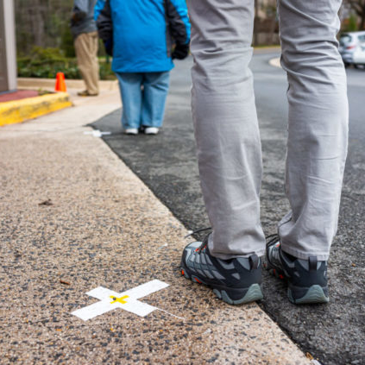 | 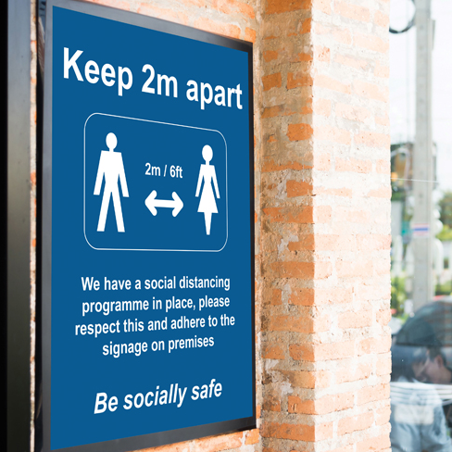 | 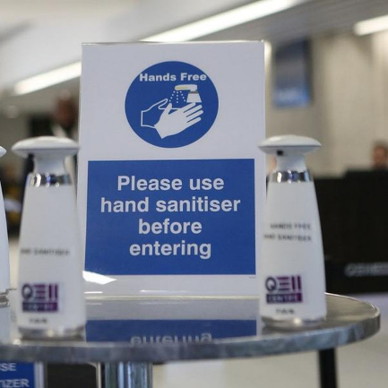
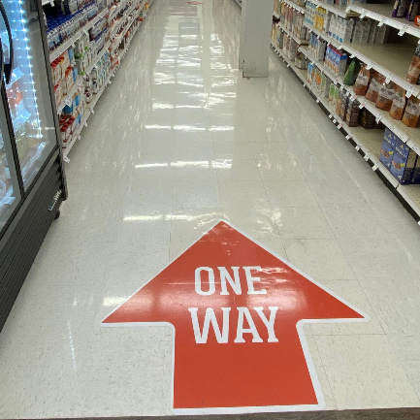 | 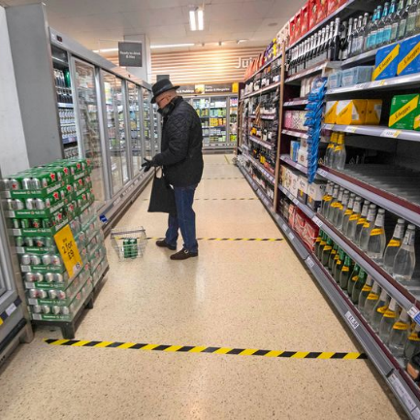 | 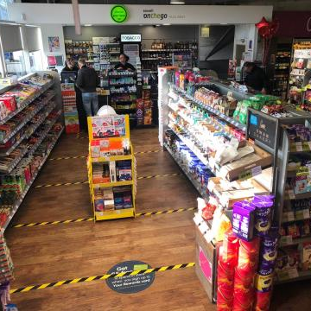
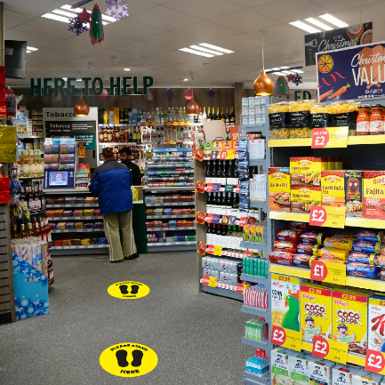 | 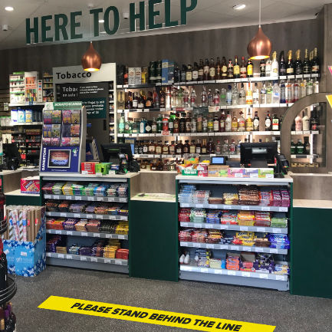 | 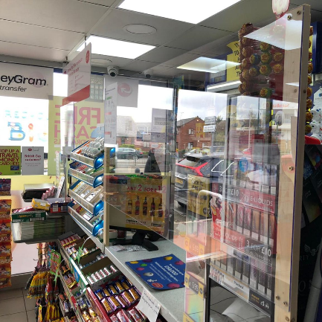

For further advice please contact Hartlepool Borough Council via email in the first instance at public.protection@hartlepool.gov.uk or alternatively on 01429 523362.

Further guidance – ‘Working Safely During Coronavirus (Covid-19)’ - is available at www.gov.uk/guidance/working-safely-during-coronavirus-covid-19

Posters to help businesses promote social distancing on their premises can be downloaded at www.hartlepool.gov.uk/social-distancing-for-businesses

