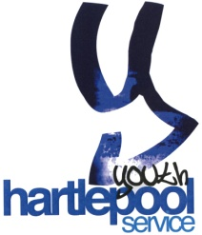 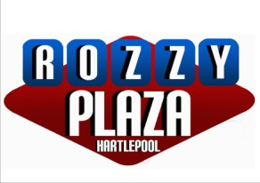

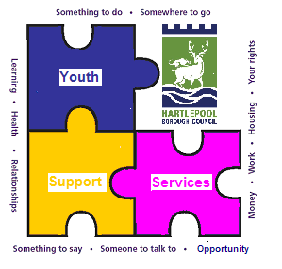

**Rozzy Plaza**

This facility has been provided and is managed by Hartlepool Borough Council.

It is for use by Skateboards, BMX and Skates

**Scooters are only permitted on Saturday and Sunday 9am until 1pm**

**Conditions of Use**

1. This facility has been designed for the use of non motorised or electrical equipment i.e. skateboards, BMX bikes and skates.
2. Please note that the Skate park is not designed for the use of scooters and use of these will result in damage to the Skate park surface and is likely to place users at risk of injury
3. The Skate park is not suitable for children under 8 years of age
4. Users fully understand and acknowledge that there are risks and dangers associated with skateboarding, BMX riding and inline skating which could result in bodily injury, partial and /or total disability, paralysis or death. All persons who use this facility do so at their own risk and assume full responsibility for their participation and for using appropriate safety equipment.
5. HBC take no responsibility for any loss or damage to any equipment whilst using this facility
6. This facility must be used for its intended purpose along with appropriate equipment
7. Appropriate protective clothing such as knee, elbow pads and wrist guards and specifically helmets must be worn at all times by all users under the age of 18. Helmets must be fastened correctly. Hartlepool Borough Council strongly recommends that all users over the age of 18 also wear helmets.
8. Prior to using any ramps, equipment or structure, users must check it for their safety and suitability for their purpose and skill level.
9. Users must immediately stop using the facilities and report any damage which may cause any possible injury to users.
10. Any accident must be reported immediately to a member of staff.
11. This facility is not to be used in wet or icy conditions. The skate park will be closed if conditions are not suitable for use
12. Consider the needs of other users of the Skatepark and Rossmere Youth Centre including all residents when leaving
13. In the interest of safety, do not bring dogs, glass, drugs or alcohol into the area.
14. The skate park and Rossmere complex is a Hartlepool Borough Council designated NO SMOKING AREA
15. Use of the skate park whilst under the influence of drugs or alcohol is not permitted
16. Place all rubbish in the bins provided and keep the skate park tidy
17. Unauthorized graffiti in the skate park will not be tolerated. Keep the skate park surfaces clean. Any graffiti will result in the skate park being closed down while it is removed.
18. Any unacceptable behaviour both inside and outside of the skate park will result in exclusion from the Rossmere complex.
19. A valid membership must be held in order to use the skate park. These are available from Rossmere Youth Centre.
20. One membership=One person entry to the site.

**Consent to participate in Rozzy Plaza Skate Park activities and events**

Inline skating, skateboarding and BMX riding can be dangerous sports, please be aware that by signing this consent form you accept that using the facilities at Rozzy Plaza Skate Park is at your own risk and you will not hold Hartlepool Borough Council liable in any way for any injuries that result from using this facility.

1. I agree for my son/daughter to take part in Rozzy Plaza skate park activities and events
2. I understand that I cannot hold Hartlepool Borough Council responsible for compensation in respect of loss or damage to personal property or for personal injury which he/she may sustain during activity
3. I understand the importance of advising Hartlepool Borough Council
4. of any medical or special needs which may require particular attention in order to enable my son/daughter full and safe participation in the activity
5. I understand that I should not permit my son/daughter to attend Rozzy Plaza if she/he is not in good health
6. If at any point in their visit he/she requires urgent medical attention and provided that I cannot be contacted personally I give permission to the medical authorities to administer any emergency treatment, including anaesthetic, which they consider necessary.
7. I understand that if my son/daughter causes harm or serious upset to a member of Rozzy Plaza or a member of staff, they will lose their membership and be asked to leave the site.
8. I have read and agree to abide by the terms and conditions of use for Rozzy Plaza (Skate Park). I also understand that not adhering to such could result in the loss of my membership.

Signed ............................................................................ Date............................................

Young person’s name ..........................................................................

Name of Parent/Guardian....................................................................