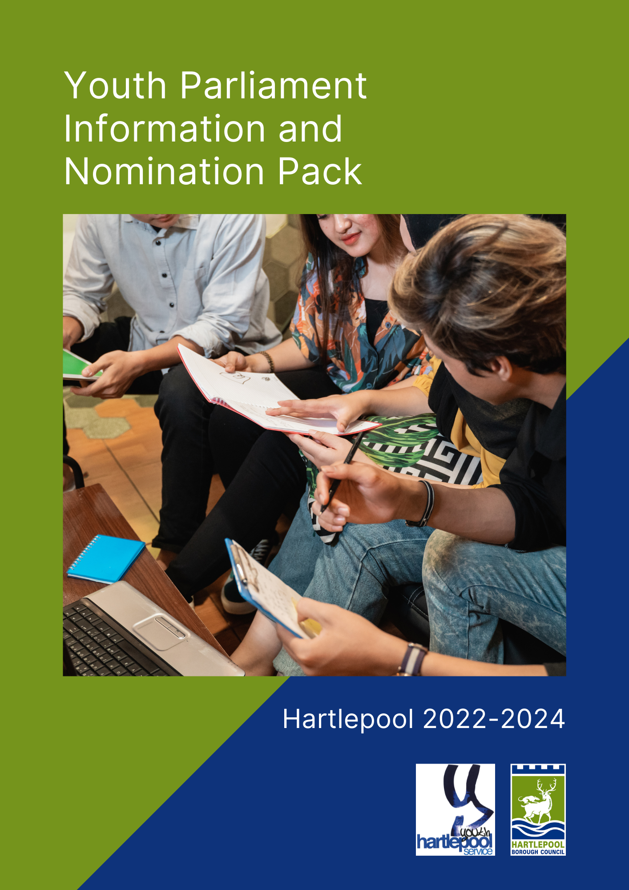

What is in this pack?

Thank you for taking an interest in potentially becoming the next Member of Youth Parliament for Hartlepool! This pack should give you all the information you need and answer any questions you may have about the process of becoming a Member of Youth Parliament.

You will also find an application form and consent forms, should you wish to apply.
If you do wish to apply you will need two references to support your application; this could be a teacher, youth worker of friend, although please be aware these people must only support one nomination.

You will then be expected to attend a development day at Throston Youth Centre (Wiltshire Way, Hartlepool, TS26 9PX) or Rossmere Youth Centre to learn more about the role of a Member of Youth Parliament and if you decide you would like to proceed with your nomination you will be supported to write your manifesto.

You can find further up to date information by visiting:
https://www.byc.org.uk/uk/uk-youth-parliament

We look forwards to receiving your application!

Table of Content:

Page 2 | What is UKYP?
Page 3 | What will be expected of me?
Page 4 | Key Dates
Page 5 | Expression of interest form
Page 8 | Photo Consent form

What is UK Youth Parliament?

The UK Youth Parliament (UKYP) is run by young people for young people and enables 18-year-olds to have the opportunity to speak about issues they are passionate about and bring about social change.

What does it mean to be a Member of Youth Parliament?

- A Member of Youth Parliament consults with other young people in their constituency – in your case, Hartlepool - and is there to represent their views.
- You will work with youth groups, councillors and decision makers on the issues that matter most to your constituents.
- You will have the opportunity to be involved in a range of campaigns, projects and events.
- You will attend local meetings.
- As a member of youth parliament you will have the opportunity to attend regional meeting during your term in office.
- You will act on the results of Make Your Mark consultations*

*The Make Your Mark consultations will be held in February 2022, the same time as the elections. The consultations give young people the chance to decide which issues are the most important to them. These are national priorities and are some of the issues that you will focus on during your term. Young people will be asked to vote won which issues are most important to them.

MYP’s are politically neutral – this is an issue-based role!

What is like being a MYP?

“I became deputy MYP in 2019 and then MYP in 2020. Our main focus was the environment where we proceeded to do things such as litter picks on beaches and in parks. We also made several surveys to gather information about what was needed in Hartlepool. It wasn’t all work however, the group would often get together simply to have fun. Once I became MYP I focused on mental health and how to improve life for young people and that is something I’m still working towards now. Being part of the youth council is an amazing experience where you can meet new people and truly make a difference. Mostly the council would be helping improve Hartlepool however that’s not all we do. BYC conventions take place which is where the youth councils from across the UK meet together and democratically vote on changes across the entirety of the UK. I have been to votes and conventions about environment, education, knife crime and many more, all of which have ended in a new law being passed or an old one being changed. You can have a chance to speak before MPs, governors and the Prime Minister. You can truly make a change here.” Ash – MYP Parliament for Hartlepool 2019-2021.

What will be expected of me?

- A Member of Youth Parliament term last for 2 years.
- The term will run from 1 March 2022 – 29th February 2024.
- You will be expected to commit between 2-5 hours a week. Please bare this in mind if you will be entering GCSE or A level years. There are no set times for you to complete these hours, but work will usually take place outside of school or college hours.
- You will be supported in your role as MYP for Hartlepool by a youth worker. They will accompany you to meetings and help ensure you can make your time as a MYP a success.

Who can apply?

Candidates must:
- Be aged 11-18 on their first day in office.
- Live, work or volunteer for a minimum of 14 hours per week or be in education for a minimum of 12 hours per week in the constituency in which they stand for election.
- You cannot stand in more than one constituency in the same year’s election.

What skills do I need?

Ideally candidates will be:
- Interested in forming opinions on topical issues
- Able to listen to and respect the views of their peer group
- Take their responsibility seriously
- Not be afraid to speak their mind

What skills will I develop?

- Communication
- Public speaking
- Develop your knowledge of politics and current affairs
- The ability to look at issues from someone else’s perspective
- Debating
- Teamwork
- Leadership
- Organisation

How do I become a MY?

By filling in the forms in this pack. You will then come along to a development day at Throston Youth Project and write your manifesto.

When the campaign period begins, your manifesto will be published and an election will take place in schools where Young people will have the opportunity to vote for who they would like to see represent them.

Key dates and time frame

Dates | Actions
November 2021 | Information packs sent to schools
29th and 30th November 2021 | Briefing evening for candidates at Throston Youth Project and Rossmere Youth Centre
Week Commencing 6th December 2021 | All nominations, including photographs and manifestos, to be completed and submitted
10th December 2021, 12:00pm | Nominations close
December 2021 – January 2022 | Campaign period begins  Statement of nominations and manifestos published
Week Commencing 24th January 2022 | Ballot boxes and paperwork delivered to schools
31st January – 11th February 2022 | Voting period begins in schools
Week Commencing 14th February 2022 | Ballots collected from schools
21st February 2022 | Elections count and announcement
Expression of Interest Form

For Election as a Member of the United Kingdom Youth Parliament to represent Young People in Hartlepool

- *Candidates MUST be aged between 11 and 18 years of age and candidates under the age of 18 must gain parent/guardians consent to participate in the elections.

- FOR MORE INFORMATION ABOUT THE UK YOUTH PARLIAMENT VISIT:- https://www.byc.org.uk/uk/uk-youth-parliament

Forename: |  |  |  | Surname:
Date of Birth: |  |  |  | Age:
Contact Number: |  |  |  | Gender:
Address:

Postcode:
Email:
School/college currently attending:
Do you consider yourself to have a special educational need and/or disability?  (Please tick one): |  | Yes No
If the answer is yes, please give us further information:
By signing this form, you formally declare that you:

- Wish to be nominated for election as a member of the UK Youth Parliament

- Have read and agreed to the terms and conditions of the election
Print name:
Signature: |  |  | Date:

Your proposer and seconder are the people
that will support your nomination
Proposer |  |  | Seconder
Name: |  |  | Name:
Contact details: |  |  | Contact details
Relationship to candidate: |  |  | Relationship to candidate:
Signature: |  |  | Signature:
Parental Content

Any candidate under the age of 18 must have the following section completed by a parent/guardian.

By signing this form, you formally declare that you:

- Give consent to the candidate specified in page 5 of this nomination pack showing an interest in the elections as a member of the UK Youth Parliament and attending a development Day at Throston Youth Project on Saturday 20th November 2021

- Have read and agreed to the terms and conditions of the election.
Print name:
Signature: |  |  |  | Date:

Candidate expression of interest

Please write below what you would like people to know about you and the issues that are important to you. (No more than 200 words)

Hartlepool Borough Council reserve the right to delete anything considered to be offensive, inappropriate, or overtly party political.
I will be available to attend the development day at Throston Youth Centre on Saturday 20th November 2021: (Please tick one) | Yes No
Photography, Filming and Publicity Consent Form

Please complete this form to give consent for us to take images, moving footage, audio and comments to then be stored and used.

This form covers consent for use of the above for internal and external communication and storage of the data within this form. All data (images, film, comments, personal info on this form), will be stored by Hartlepool Borough Council.

The data may be shared with third-party organisations in order to fulfil the communication work necessary (for example providing images to design/print agencies).

Section A: About You

Full Name:
Address:
Telephone:
Email:

Section B: About the event, project or campaign

Description of event, project or campaign:
Location:
Date:

Section C: Your consent

I give consent to Hartlepool Borough Council to publish, republish, or otherwise transmit still and moving images, audio and my name for the purposes of:

Publicity and promotional materials, including advertising material and printed publications

Presentation and exhibition materials

Websites, social media channels and digital communications materials, including advertising material and printed publications

News media and their associated websites, social media channels, print publications, television, and radio

I understand the Council will keep all its images in accordance with data protection law and delete the images that have not been used for any publicity or marketing after two years. I also understand that the still/moving images/audio used for publicity or marketing purposes are in the public domain and therefore could potentially be reproduced, altered, or re-used by people outside of Hartlepool Borough Council’s control. I know I have the right to withdraw consent at any time by emailing communications@hartlepool.gov.uk or by calling 01429 523578, but understand that withdrawing consent may not affect the material that has already been used.

Section D: Your signature

I am the person identified in Section A and in the photograph(s), filming and/or recording. I understand the above request and give informed consent.

Signature of candidate:
Print name:
Date:

Section E: Signing on behalf of a person aged under 16

I am the parent/guardian (delete as appropriate) of the person identified in Section A and in the photograph(s), filming and/or recording. I understand the above request and give informed consent for this person’s image/data to be used.

Signature of parent/guardian:
Print name:
Date:

Please return the above forms to rachael.garlick@hartlepool.gov.uk by
noon on Friday 19th November 2021

ANY QUESTIONS ABOUT YOUR NOMINATION PLEASE CONTACT
Rachael Garlick on
rachael.garlick@hartlepool.gov.uk

