THE LICENSING ACT 2003

PREMISES LICENCE SUMMARY (PART B)

Premises licence number | HART/PS/349

Premises details
Postal address of premises or, if none, ordnance survey map reference, or description

A19 Services Northbound
Elwick

Post Town Hartlepool | Post Code TS27 3HH

Telephone number 01740 644 223

Where the licence is time limited the dates
N/A

Licensable activities authorised by the licence. Any entertainment authorised by this licence is limited to indoors only, unless stated otherwise.

Alcohol Sales (Off Licence)

The times the licence authorises the carrying out of licensable activities

Monday to Sunday 0600 - 2200

The opening hours of the premises

Monday to Sunday 0600 - 2200

Where the licence authorises supplies of alcohol whether these are on and / or off supplies

Off sales only

Name, (registered) address of holder of premises licence

Ron Perry & Son Limited
A19 Services Northbound
Elwick
Hartlepool
TS27 3HH

Registered number of holder, for example company number, charity number (where applicable)

1403530

Name of designated premises supervisor where the premises licence authorises for the supply of alcohol

Brian McGregor

State whether access to the premises by children is restricted or prohibited

Unrestricted

Date Licence Granted: 16th May 2019

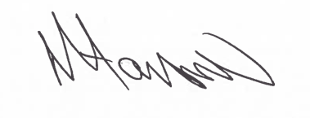
Assistant Director
(Environment & Neighbourhood Services)

The Licensing Section
Public Protection Division
Hartlepool Borough Council
Civic Centre
Victoria Road
Hartlepool
TS24 8AY

