

THE LICENSING ACT 2003

PREMISES LICENCE SUMMARY (PART B)

Premises licence number | HART/PS/468

Premises details
Postal address of premises or, if none, ordnance survey map reference, or description
Marks & Spencer Simply Food
Unit 2
Anchor Retail Park
Marina Way

Post Town Hartlepool | Post Code TS24 0XR

Telephone number

Where the licence is time limited the dates

Effective from 5th May 2015

Licensable activities authorised by the licence. Any entertainment authorised by this licence is limited to indoors only, unless stated otherwise.

Supply of Alcohol

This licence does not authorise the provision of adult entertainment.

The times the licence authorises the carrying out of licensable activities

Shop Area Monday – Sunday 06:00 – 00:00 (Off Sales)

Café Monday – Sunday 08:00 – 23:00 (On Sales)

The opening hours of the premises

Monday – Sunday 06:00 – 00:00

Where the licence authorises supplies of alcohol whether these are on and / or off supplies

On Sales – Café area only
Off Sales – Shop area only

Name, (registered) address of holder of premises licence

Marks & Spencer Simply Foods Limited
35 North Wharf Road
Paddington
London
W2 1NW

Registered number of holder, for example company number, charity number (where applicable)

04739922

Name of designated premises supervisor where the premises licence authorises for the supply of alcohol

Marilyn Burdis

State whether access to the premises by children is restricted or prohibited

Unrestricted

Date Licence Granted: 4th April 2022

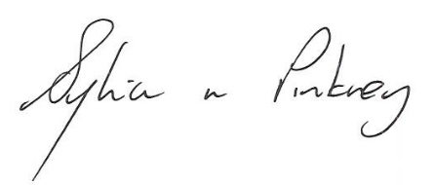
Sylvia Pinkney
Assistant Director
(Regulatory Services)

The Licensing Section
Hartlepool Borough Council
Civic Centre
Victoria Road
Hartlepool
TS24 8AY

