THE LICENSING ACT 2003

PREMISES LICENCE SUMMARY (PART B)

Premises licence number | HART/PS/335

Premises details
Postal address of premises or, if none, ordnance survey map reference, or description

A19 Services Southbound
Elwick

Post Town Hartlepool | Post Code TS27 3HH
Telephone number 01740644342

Where the licence is time limited the dates
N/A

Licensable activities authorised by the licence. Any entertainment authorised by this licence is limited to indoors only, unless stated otherwise.

1 The supply of alcohol
2 The provision of late night refreshments

The times the licence authorises the carrying out of licensable activities

1 Supply of Alcohol Monday to Sunday 00:00 – 24:00
2 Late Night Refreshment Monday to Sunday 23:00 – 05:00

The opening hours of the premises

Monday to Sunday 00:00 – 24:00

Where the licence authorises supplies of alcohol whether these are on and / or off supplies

Off sales only

Name, (registered) address of holder of premises licence

Ron Perry & Son Limited
A19 Services Southbound
Elwick
Hartlepool
TS27 3HH

Registered number of holder, for example company number, charity number (where applicable)

1403530

Name of designated premises supervisor where the premises licence authorises for the supply of alcohol

Brian McGregor

State whether access to the premises by children is restricted or prohibited

Unrestricted

Licence Authorised By: 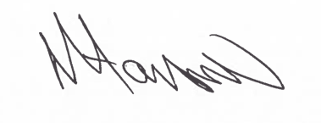

Assistant Director
Environment & Neighbourhood Services)

Date Licence Granted: 16th May 2019

The Licensing Section
Public Protection Division
Hartlepool Borough Council
Civic Centre
Victoria Road
Hartlepool
TS24 8AY

