

THE LICENSING ACT 2003

PREMISES LICENCE SUMMARY (PART B)

Premises licence number | HART/PS/580

Premises details
Postal address of premises or, if none, ordnance survey map reference, or description

Ashfield Caravan Park
Ashfield Farm
Dalton Piercy

Post Town Hartlepool | Post Code TS27 3HY

Telephone number

Where the licence is time limited the dates

N/A

Licensable activities authorised by the licence. Any entertainment authorised by this licence is limited to indoors only, unless stated otherwise.

Supply of Alcohol

This licence does not authorise the provision of adult entertainment.

The times the licence authorises the carrying out of licensable activities

Monday – Saturday 12:00 - 23:00
Sunday 12:00 – 22:00

The opening hours of the premises

Monday – Saturday 12:00 - 23:00
Sunday 12:00 – 22:00

Where the licence authorises supplies of alcohol whether these are on and / or off supplies

On Sales Only

Name, (registered) address of holder of premises licence

M&A Ashton Ltd
10 Hillcrest Grove
Elwick Village
Hartlepool
TS27 3EH

Registered number of holder, for example company number, charity number (where applicable)

13898539

Name of designated premises supervisor where the premises licence authorises for the supply of alcohol

Andrea Ashton

State whether access to the premises by children is restricted or prohibited

Restricted

Date Licence Granted: 11th March 2022

Licence Authorised by: 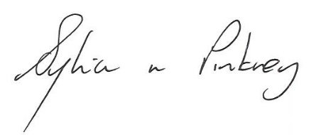

Sylvia Pinkney
Assistant Director, (Regulatory Services)

The Licensing Section
Public Protection Division
Hartlepool Borough Council
Civic Centre
Victoria Road
Hartlepool
TS24 8AY

