THE LICENSING ACT 2003

PREMISES LICENCE SUMMARY (PART B)

Premises licence number | HART/PS/366

Premises details
Postal address of premises or, if none, ordnance survey map reference, or description

1a & 1b Belle Vue Way

Post Town Hartlepool | Post Code TS25 1XJ

Telephone number 07815902943

Where the licence is time limited the dates
N/A

Licensable activities authorised by the licence. Any entertainment authorised by this licence is limited to indoors only, unless stated otherwise.

Supply of alcohol

The times the licence authorises the carrying out of licensable activities

Supply of alcohol Mondays – Saturday 0800 – 2300
Sundays - 1000 - 2230

The opening hours of the premises

Monday – Saturday 0700 – 2300
Sundays 0700 - 2230

Where the licence authorises supplies of alcohol whether these are on and / or off supplies

Off sales only

Name, (registered) address of holder of premises licence

Mr Gunathas Gunaratnam
27 Grosvenor Road
Middlesbrough
TS5 5BU

Registered number of holder, for example company number, charity number (where applicable)

Name of designated premises supervisor where the premises licence authorises for the supply of alcohol

Selvendran Selvarajah

State whether access to the premises by children is restricted or prohibited

Unrestricted

Date Licence Granted: 15th November 2021

Licence Authorised By:

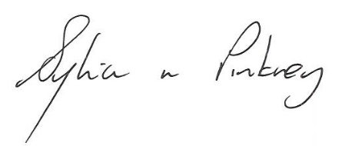

Sylvia Pinkney
Assistant Director
(Regulatory Services)

The Licensing Section
Public Protection Division
Hartlepool Borough Council
Civic Centre
Victoria Road
Hartlepool
TS24 8AY

