THE LICENSING ACT 2003

PREMISES LICENCE SUMMARY (PART B)

Premises licence number | HART/PS/351e

Premises details
Postal address of premises or, if none, ordnance survey map reference, or description

Tesco Hartlepool Extra (02638)
Belle Vue Way

Post Town Hartlepool | Post Code TS25 1JZ

Telephone number 0845 6779335

Where the licence is time limited the dates

N/A

Licensable activities authorised by the licence. Any entertainment authorised by this licence is limited to indoors only, unless stated otherwise.

Alcohol Sales
Off Licence

The times the licence authorises the carrying out of licensable activities

Alcohol Sales
Off Licence Monday to Sunday 00:01 – 00:00

The opening hours of the premises

Mondays 08:00 – 00:00
Tuesdays to Fridays 00:01 – 00:00
Saturdays 00:01 – 22:00
Sundays 10:00 – 16:00

Where the licence authorises supplies of alcohol whether these are on and / or off supplies

Off Sales Only

Name, (registered) address of holder of premises licence

Tesco Stores Limited
Tesco House
Shire Park
Welwyn Garden City
Hertfordshire
AL7 1GA

Registered number of holder, for example company number, charity number (where applicable)

Company Number: 00519500

Name of designated premises supervisor where the premises licence authorises for the supply of alcohol

Mrs Karen Patricia Illingworth

State whether access to the premises by children is restricted or prohibited

Unrestricted

Date Licence Granted: 21st May 2018

Licence Authorised by:

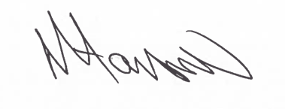

Tony Hanson, Assistant Director
(Environment and Neighbourhood Services)

The Licensing Section
Hartlepool Borough Council
Civic Centre
Victoria Road
Hartlepool
TS24 8AY

