THE LICENSING ACT 2003

PREMISES LICENCE SUMMARY (PART B)

Premises licence number | HART/PS/005

Premises details

Postal address of premises or, if none, ordnance survey map reference, or description

McColls
410/412 Catcote Road

Post Town Hartlepool | Post code TS25 2LS

Telephone number 01429 265775

Where the licence is time limited the dates

N/A

Licensable activities authorised by the licence

Alcohol Sales
Off-Licence

The times the licence authorises the carrying out of licensable activities

Alcohol Sales
Off-Licence: Monday to Saturday 0800 – 2300
Sunday 1000 – 2230
Christmas Day – 1200 – 1500 and 1900 – 2230
Good Friday – 0800 - 2230

The opening hours of the premises

Unrestricted under this legislation

Where the licence authorises supplies of alcohol whether these are on and / or off supplies

Off Sales

Name, (registered) address of holder of premises licence

Martin McColl Limited
Martin McColl House
Ashwells Road
Brentwood
Essex
CM15 9ST

Registered number of holder, for example company number, charity number (where applicable)

298945

Name of designated premises supervisor where the premises licence authorises for the supply of alcohol

Thomas William Farrow

State whether access to the premises by children is restricted or prohibited

Unrestricted

Date licence granted: 8th October 2018

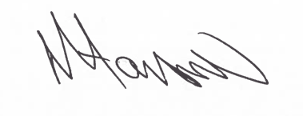

Assistant Director
(Environment & Neighbourhood Services)

The Licensing Section
Public Protection Division
Hartlepool Borough Council
Civic Centre
Victoria Road
Hartlepool
TS24 8AY

