

THE LICENSING ACT 2003

PREMISES LICENCE SUMMARY (PART B)

Premises licence number | HART/PS/448

Premises details
Postal address of premises or, if none, ordnance survey map reference, or description
Church Square
Upper Church Square

Post Town Hartlepool | Post Code TS24 7EQ

Telephone number

Where the licence is time limited the dates

N/A

Licensable activities authorised by the licence. Any entertainment authorised by this licence is limited to indoors only, unless stated otherwise.

- Supply of Alcohol
- Plays
- Films
- Live Music
- Recorded Music
- Performances of Dance
- Anything similar to 4, 5 or 6 above

Entertainment is authorised for both Indoors and Outdoors.
This licence does not authorise the provision of adult entertainment.

The times the licence authorises the carrying out of licensable activities

All the above licensable activities
Monday – Sunday 09:00 – 24:00

Events restricted to a maximum of 12 per year

The opening hours of the premises

Monday – Sunday 09:00 – 24:00

Where the licence authorises supplies of alcohol whether these are on and / or off supplies
On and Off Sales

Name, (registered) address of holder of premises licence

Hartlepool Borough Council
Sir William Gray House
Clarence Road
Hartlepool
TS24 8BT

Registered number of holder, for example company number, charity number (where applicable)

N/A

Name of designated premises supervisor where the premises licence authorises for the supply of alcohol

Aaron Joseph David Bowman

State whether access to the premises by children is restricted or prohibited

Unrestricted

Date Licence Granted: 17th June 2021

Licence Authorised by:

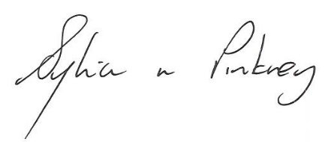
Sylvia Pinkney
Assistant Director
(Regulatory Services)

The Licensing Section
Public Protection Division
Hartlepool Borough Council
Civic Centre
Victoria Road
Hartlepool
TS24 8AY

