THE LICENSING ACT 2003

PREMISES LICENCE SUMMARY (PART B)

Premises licence number | HART/PS/191

Premises details
Postal address of premises or, if none, ordnance survey map reference, or description

Hartlepool Art Gallery
Church Square

Post Town Hartlepool | Post Code TS24 7EU

Telephone number 01429 869706

Where the licence is time limited the dates

N/A

Licensable activities authorised by the licence. Any entertainment authorised by this licence is limited to indoors only, unless stated otherwise.

Alcohol Sales (On Licence)

Entertainment
- Plays 5. Performance of Dance
- Films 6. Anything similar to 3, 4 or 5 above
- Live Music
- Recorded Music

The times the licence authorises the carrying out of licensable activities

Alcohol Sales (On & Off Licence)
Monday to Sunday 11:00 – 23:00

Entertainment
- Plays 5. Performance of Dance
- Films 6. Anything similar to 3, 4 or 5 above
- Live Music
- Recorded Music
Monday to Sunday 10:00 – 23:00

The opening hours of the premises

Monday to Sunday 10:00 – 23:00

Where the licence authorises supplies of alcohol whether these are on and / or off supplies

On Sales

Name, (registered) address of holder of premises licence

Hartlepool Borough Council
Civic Centre
Hartlepool
TS24 8AY

Registered number of holder, for example company number, charity number (where applicable)

N/A

Name of designated premises supervisor where the premises licence authorises for the supply of alcohol

Mr Robert Andrew Scott

State whether access to the premises by children is restricted or prohibited

Restricted

Date Licence Granted: 17th August 2018

Licence Authorised by:

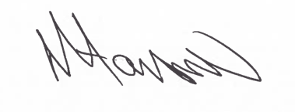

Tony Hanson, Assistant Director
(Environment and Neighbourhood Services)

The Licensing Section
Public Protection & Housing
Hartlepool Borough Council
Civic Centre, Victoria Road
Hartlepool, TS24 8AY

