THE LICENSING ACT 2003

PREMISES LICENCE SUMMARY (PART B)

Premises licence number | HART/PS/299

Premises details
Postal address of premises or, if none, ordnance survey map reference, or description

15 Church Street

Post Town Hartlepool | Post Code TS24 7DJ

Telephone number 01429 272800

Where the licence is time limited the dates

N/A

Licensable activities authorised by the licence. Any entertainment authorised by this licence is limited to indoors only, unless stated otherwise.

Provision of Late Night Refreshment

The times the licence authorises the carrying out of licensable activities

Late Night Refreshment

Sunday - Wednesday 2300 – 0100
Thursday – Saturday 2300 – 0430

Sundays preceded by Bank Holiday Monday 2300 - 0430

The opening hours of the premises

Sunday – Wednesday 0800 – 0100
Thursday – Saturday 0800 – 0430

Sundays preceding a Bank Holiday Monday 0800 – 0430

Where the licence authorises supplies of alcohol whether these are on and / or off supplies

N/A

Name, (registered) address of holder of premises licence

Mr Brett Wilkinson
Oakengates
Cresswell Drive
Hartlepool
TS26 0EQ

Registered number of holder, for example company number, charity number (where applicable)

N/A

Name of designated premises supervisor where the premises licence authorises for the supply of alcohol

N/A

State whether access to the premises by children is restricted or prohibited

Unrestricted

Date Licence Granted: 6th July 2018

Licence Authorised by:

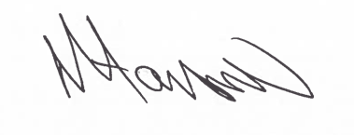
Assistant Director
(Environment & Neighbourhood Services)

The Licensing Section
Hartlepool Borough Council
Civic Centre
Victoria Road
Hartlepool
TS24 8AY

