THE LICENSING ACT 2003

PREMISES LICENCE SUMMARY (PART B)

Premises licence number | HART/PS/280

Premises details
Postal address of premises or, if none, ordnance survey map reference, or description

19 Church Street

Post Town Hartlepool | Post Code TS24 7DH

Telephone number 01429 266777/278845

Where the licence is time limited the dates

N/A

Licensable activities authorised by the licence. Any entertainment authorised by this licence is limited to indoors only, unless stated otherwise.

1. Recorded Music
2. Provision of Late Night Refreshment

The times the licence authorises the carrying out of licensable activities

1. Recorded Music

Sunday to Wednesday 1600 – 0100
Thursday to Saturday 1600 – 0200

2. Provision of late Night Refreshment

Sunday to Wednesday 1600 – 0100
Thursday to Saturday 1600 – 0200

On the night preceding Bank Holidays licensable activities can continue until 0200

The opening hours of the premises

Sunday to Wednesday 1600 – 0100
Thursday to Saturday 1600 – 0200

On the night preceding Bank Holidays the premises can remain open until 0200

Where the licence authorises supplies of alcohol whether these are on and / or off supplies

N/A

Name, (registered) address of holder of premises licence

Mr Mahir Faisal Mollik
13 Grange Road
Hartlepool
TS26 8JE

Registered number of holder, for example company number, charity number (where applicable)

N/A

Name of designated premises supervisor where the premises licence authorises for the supply of alcohol

N/A

State whether access to the premises by children is restricted or prohibited

Unrestricted

Date Licence Granted: 23rd June 2020

Licence Authorised by: 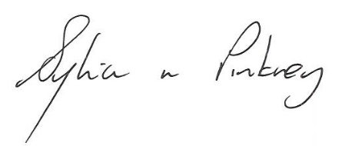
Sylvia Pinkney
Assistant Director, (Regulatory Services)

The Licensing Section, Hartlepool Borough Council, Civic Centre
Victoria Road, Hartlepool, TS24 8AY

