THE LICENSING ACT 2003

PREMISES LICENCE SUMMARY (PART B)

Premises licence number | HART/PS/080

Premises details

Postal address of premises or, if none, ordnance survey map reference, or description

20-21 Church Street

Post Town Hartlepool | Post code TS24 7DH

Telephone number 01429 867739

Where the licence is time limited the dates

N/A

Licensable activities authorised by the licence

Alcohol Sales - On and Off sales
Recorded Music
Late Night Refreshment

The times the licence authorises the carrying out of licensable activities

Alcohol Sales

Monday – Saturday 11:00 – 00:00
Sunday, Christmas Day, Good Friday 12:00 – 23:30

Recorded Music Monday – Sunday 11:00 – 00:00

Late Night Refreshment

Monday – Saturday 11:00 – 00:30
Sunday, Christmas Day, Good Friday 12:00 – 00:00

The opening hours of the premises

At the discretion of the licensee

Where the licence authorises supplies of alcohol whether these are on and / or off supplies

On and Off sales

Name, (registered) address of holder of premises licence

Mr Diar Anwar Kareem
20-21 Church Street
Hartlepool
TS24 7DH
Registered number of holder, for example company number, charity number (where applicable)

Name of designated premises supervisor where the premises licence authorises for the supply of alcohol
Mr Diar Anwar Kareem

State whether access to the premises by children is restricted or prohibited

Unrestricted

Date licence granted: 15th January 2018

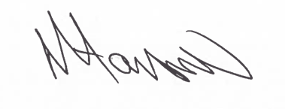
Assistant Director
(Environment & Neighbourhood Services)

The Licensing Section
Public Protection Division
Hartlepool Borough Council
Civic Centre
Victoria Road
Hartlepool
TS24 8AY

