THE LICENSING ACT 2003

PREMISES LICENCE SUMMARY (PART B)

Premises licence number | HART/PS/389

Premises details
Postal address of premises or, if none, ordnance survey map reference, or description

69 - 72 Church Street

Post Town Hartlepool | Post Code TS24 7DN

Telephone number

Where the licence is time limited the dates
N/A

Licensable activities authorised by the licence. Any entertainment authorised by this licence is limited to indoors only, unless stated otherwise.

1. Supply of Alcohol 4. Performance of Dance
2. Live Music 5. Provision of Facilities for Dancing
3. Recorded Music

The times the licence authorises the carrying out of licensable activities

Alcohol

Monday to Sunday (inclusive) 11:00 – 03:30

Live Music, Recorded Music, Performance of Dance, Provision of Facilities for Dancing

Monday to Sunday (inclusive) 11:00 – 04:00

Late Night Refreshments 11:00 – 02:00

Monday to Sunday (inclusive) 11:00 – 02:00

The opening hours of the premises

Monday to Sunday (inclusive) 11:00 – 04:00

Where the licence authorises supplies of alcohol whether these are on and / or off supplies

On & Off Sales

Name, (registered) address of holder of premises licence

MAMC Enterprise Ltd
Morton House
Fence Houses
Houghton Le Spring
DH4 6QA

Registered number of holder, for example company number, charity number (where applicable)

12722078

Name of designated premises supervisor where the premises licence authorises for the supply of alcohol

Randeep Singh Nanan

State whether access to the premises by children is restricted or prohibited

Restricted

Date Licence Granted: 28th July 2021

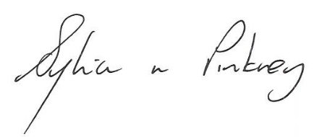
Sylvia Pinkney
Assistant Director
(Regulatory Services)

The Licensing Section
Public Protection Division
Hartlepool Borough Council
Civic Centre
Victoria Road
Hartlepool
TS24 8AY

