THE LICENSING ACT 2003

PREMISES LICENCE SUMMARY (PART B)

Premises licence number | HART/PS/270

Premises details
Postal address of premises or, if none, ordnance survey map reference, or description

Mehrab Tandoori
74 Church Street

Post Town Hartlepool | Post Code TS24 7DN

Telephone number

Where the licence is time limited the dates

N/A

Licensable activities authorised by the licence. Any entertainment authorised by this licence is limited to indoors only, unless stated otherwise.

Alcohol Sales (On & Off Sales)

Late Night Refreshment

The times the licence authorises the carrying out of licensable activities

Alcohol Sales (On & Off Sales)
Monday to Sunday 18:00 – 03:00

Late Night Refreshment
Monday to Sunday 23:00 – 03:00

The opening hours of the premises

Monday to Sunday 18:00 – 03:00

Where the licence authorises supplies of alcohol whether these are on and / or off supplies

On & Off Sales

Name, (registered) address of holder of premises licence

Mehrab Tandoori Limited
74 Church Street
Hartlepool
TS24 7DN

Registered number of holder, for example company number, charity number (where applicable)

10767828

Name of designated premises supervisor where the premises licence authorises for the supply of alcohol

Shafna Begum

State whether access to the premises by children is restricted or prohibited

Restricted

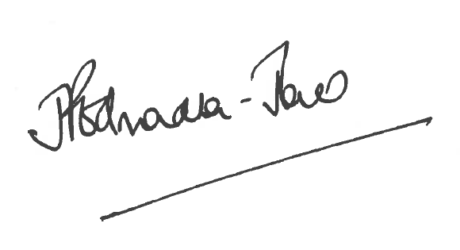
Director of Public Health

Date Licence Granted: 10th October 2017

The Licensing Section
Public Protection and Housing
Hartlepool Borough Council
Civic Centre
Victoria Road
Hartlepool
TS24 8AY

