
THE LICENSING ACT 2003

PREMISES LICENCE SUMMARY (PART B)

Premises licence number | HART/PS/556

Premises details
Postal address of premises or, if none, ordnance survey map reference, or description
Unit 1
Central Buildings
Church Street

Post Town Hartlepool | Post Code TS24 7EB

Telephone number 07904922522

Where the licence is time limited the dates

Licensable activities authorised by the licence. Any entertainment authorised by this licence is limited to indoors only, unless stated otherwise.

1. Recorded Music
2. Alcohol Sales (on sales)

This licence does not authorise the provision of adult entertainment.

The times the licence authorises the carrying out of licensable activities

1. Recorded Music Monday – Friday 09:00 – 18:00
Saturday 10:00 – 18:00
Sunday 10:00 – 16:00

2. Alcohol Sales (on sales) Monday – Friday 09:00 – 18:00
Saturday 10:00 – 18:00
Sunday 10:00 – 16:00

The opening hours of the premises

Monday – Friday 09:00 – 18:00
Saturday 10:00 – 18:00
Sunday 10:00 – 16:00
All Bank Holidays 10:00 – 16:00

Where the licence authorises supplies of alcohol whether these are on and / or off supplies

On Sales

Name, (registered) address of holder of premises licence

Louise Carr
30 Dewberry Close
Hartlepool
TS26 0WE

Registered number of holder, for example company number, charity number (where applicable)

N/A

Name of designated premises supervisor where the premises licence authorises for the supply of alcohol

Louise Carr

State whether access to the premises by children is restricted or prohibited

Restricted

Date Licence Granted: 19th February 2020

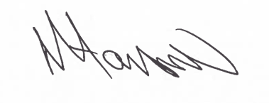

Tony Hanson
Assistant Director
(Environment & Neighbourhood Services)

The Licensing Section
Hartlepool Borough Council
Civic Centre
Victoria Road
Hartlepool
TS24 8AY

