THE LICENSING ACT 2003

PREMISES LICENCE SUMMARY (PART B)

Premises licence number | HART/PS/363

Premises details
Postal address of premises or, if none, ordnance survey map reference, or description

Hartlepool Smallcrafts Association
Commercial Street
Middleton Road

Post Town Hartlepool | Post Code TS24 0SA

Telephone number 01429 266922

Where the licence is time limited the dates
N/A

Licensable activities authorised by the licence. Any entertainment authorised by this licence is limited to indoors only, unless stated otherwise.

1. Supply of Alcohol
2. Films
3. Indoor Sporting Activities
4. Live Music
5. Recorded Music
6. Performance of Dance
7. Provision of Facilities for Making Music
8. Provision of Facilities for Dancing
9. Facilities Similar to 7 or 8 above

The times the licence authorises the carrying out of licensable activities

Monday to Saturday 11:00 – 01:30
Sunday 10:00 – 01:30

The opening hours of the premises

Monday to Saturday 11:00 – 01:30
Sunday 10:00 – 01:30

Where the licence authorises supplies of alcohol whether these are on and / or off supplies

On and Off Supplies

Name, (registered) address of holder of premises licence

Hartlepool Smallcrafts Association
Commercial Street
Middleton
Hartlepool
TS24 0SA

Registered number of holder, for example company number, charity number (where applicable)

N/A

Name of designated premises supervisor where the premises licence authorises for the supply of alcohol

Kirsty Playfor

State whether access to the premises by children is restricted or prohibited

Restricted

Date Licence Granted: 24th April 2018

Licence Authorised by:
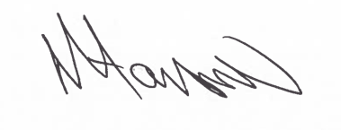

Tony Hanson, Assistant Director
(Environment and Neighbourhood Services)

The Licensing Section
Public Protection Division
Hartlepool Borough Council
Civic Centre
Victoria Road
Hartlepool
TS24 8AY

