THE LICENSING ACT 2003

PREMISES LICENCE SUMMARY (PART B)

Premises licence number | HART/PS/154

Premises details

Postal address of premises or, if none, ordnance survey map reference, or description

Aldi Stores Limited
Dunston Road

Post Town Hartlepool | Post code TS26 0EN

Telephone number 01827 710800

Where the licence is time limited the dates

N/A

Licensable activities authorised by the licence

Alcohol Sales

Off sales

The times the licence authorises the carrying out of licensable activities

Alcohol Sales

Off sales Monday – Saturday 08:00 – 23:00
Sunday 10:00 – 22:30
Good Friday 08:00 – 22:30
16th December – 1st January 06:00 – 00:00

The opening hours of the premises

Off sales Monday – Saturday 08:00 – 23:00
Sunday 10:00 – 22:30
Good Friday 08:00 – 22:30
16th December – 1st January 06:00 – 00:00

Where the licence authorises supplies of alcohol whether these are on and / or off supplies

Off sales

Name, (registered) address of holder of premises licence

Aldi Stores Limited
Holly Lane
Atherstone
Warwickshire
CV9 2SQ

Registered number of holder, for example company number, charity number (where applicable)

2321869

Name of designated premises supervisor where the premises licence authorises for the supply of alcohol

Gary Iveson

State whether access to the premises by children is restricted or prohibited

Unrestricted

Date licence granted: 26th October 202

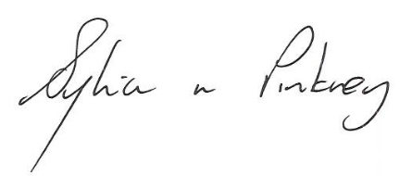
Sylvia Pinkney
Assistant Director
(Regulatory Services)

The Licensing Section
Public Protection Division
Hartlepool Borough Council
Civic Centre
Victoria Road
Hartlepool
TS24 8AY

