THE LICENSING ACT 2003

PREMISES LICENCE SUMMARY (PART B)

Premises licence number | HART/PS/333

Premises details

Postal address of premises or, if none, ordnance survey map reference, or description

Spar Store
50 -52 Elizabeth Way
Seaton Carew

Post Town Hartlepool | Post code TS25 2AX

Telephone number 01429 269348

Where the licence is time limited the dates

N/A

Licensable activities authorised by the licence

Alcohol Sales

Off-Licence

The times the licence authorises the carrying out of licensable activities

Alcohol Sales

Off-Licence Monday – Sunday 0700 – 2200

The opening hours of the premises

Monday – Sunday 0700 – 2200

Where the licence authorises supplies of alcohol whether these are on and / or off supplies

Off-sales

Name, (registered) address of holder of premises licence

James Hall & Co (Southport) Ltd
SPAR Distribution Centre
Bowland View
Preston
Lancashire
PR2 5QT

Registered number of holder, for example company number, charity number (where applicable)

I022295

Name of designated premises supervisor where the premises licence authorises for the supply of alcohol
Joanne Young-Winter

State whether access to the premises by children is restricted or prohibited

Unrestricted

Date licence granted: 28th June 2021

Licence Authorised by:

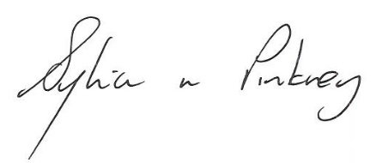
Sylvia Pinkney
Assistant Director
(Regulatory Services)

The Licensing Section
Public Protection Division
Hartlepool Borough Council
Civic Centre
Victoria Road
Hartlepool
TS24 8AY

