

THE LICENSING ACT 2003

PREMISES LICENCE SUMMARY (PART B)

Premises licence number | HART/474

Premises details
Postal address of premises or, if none, ordnance survey map reference, or description
Abbey Stores
54 Elizabeth Way

Post Town Hartlepool | Post Code TS25 2AX

Telephone number

Where the licence is time limited the dates

N/A

Licensable activities authorised by the licence. Any entertainment authorised by this licence is limited to indoors only, unless stated otherwise.

Supply of Alcohol

This licence does not authorise the provision of adult entertainment.

The times the licence authorises the carrying out of licensable activities

Monday to Sunday 07:00 -22:00

The opening hours of the premises

Monday to Sunday 06:00 -23:00

Where the licence authorises supplies of alcohol whether these are on and / or off supplies

Off Safes

Name, (registered) address of holder of premises licence

Mr Gabriel Khristian
32 Sedgewick Close
Hartlepool
TS24 9EU

Registered number of holder, for example company number, charity number (where applicable)

N/A

Name of designated premises supervisor where the premises licence authorises for the supply of alcohol

Piramila Mathiyalkan

State whether access to the premises by children is restricted or prohibited

Unrestricted

Date Licence Granted: 17th December 2014

Signed: 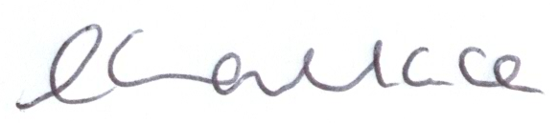

Director of Public Health

The Licensing Section
Hartlepool Borough Council
Civic Centre
Victoria Road
Hartlepool
TS24 8AY

