THE LICENSING ACT 2003

PREMISES LICENCE SUMMARY (PART B)

Premises licence number | HART/PS/373

Premises details
Postal address of premises or, if none, ordnance survey map reference, or description

Hornby Park
Elizabeth Way
Seaton Carew

Post Town Hartlepool | Post Code TS25 2AZ

Telephone number 01429 260945

Where the licence is time limited the dates
N/A

Licensable activities authorised by the licence. Any entertainment authorised by this licence is limited to indoors only, unless stated otherwise.

1 | Supply of alcohol | 2 | Live Music
3 | Recorded Music | 4 | Performance of Dance
5 | Anything similar to 2, 3 or 4 | 6 | Provision of facilities for making music
7 | Provision of facilities for dancing | 8 | Provision of entertainment facilities of a similar description to 6 or 7
Live Music is restricted to a maximum of four weekends per calendar year

The times the licence authorises the carrying out of licensable activities

1 | Supply of alcohol – Saturdays and Sundays 1200 – 1830
2 | Live Music – Saturday and Sundays 1200 – 1900
3 | Recorded Music - Saturday and Sundays 1200 – 1900
4 | Performance of Dance - Saturday and Sundays 1200 – 1900
5 | Anything similar to 2, 3 or 4 - Saturday and Sundays 1200 – 1900
6 | Provision of facilities for making music - Saturday and Sundays 1200 – 1900
7 | Provision of facilities for dancing - Saturday and Sundays 1200 – 1900
8 | Provision of entertainment facilities of a similar description to 6 or 7 - Saturday and Sundays 1200 – 1900

The opening hours of the premises

Saturdays and Sundays 1200 – 1900

Where the licence authorises supplies of alcohol whether these are on and / or off supplies

On supplies only

Name, (registered) address of holder of premises licence

Hornby park Ltd
Hornby Park
Elizabeth Way
Seaton Carew
Hartlepool
TS25 2AZ

Registered number of holder, for example company number, charity number (where applicable)

12299635

Name of designated premises supervisor where the premises licence authorises for the supply of alcohol

Andrew Reece

State whether access to the premises by children is restricted or prohibited

Unrestricted

Date Licence Granted: 8th March 2021

Licence Authorised By:
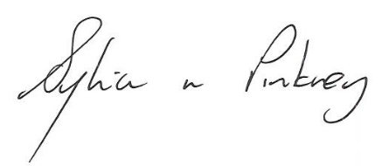
Sylvia Pinkney
Assistant Director
(Regulatory Services)

The Licensing Section
Public Protection Division
Hartlepool Borough Council
Civic Centre
Victoria Road
Hartlepool
TS24 8AY

