THE LICENSING ACT 2003

PREMISES LICENCE SUMMARY (PART B)

Premises licence number | HART/PS/244

Premises details

Postal address of premises or, if none, ordnance survey map reference, or description

Morrisons Daily
79/81 Elwick Road

Post Town Hartlepool | Post code TS25 1DS

Telephone number 01429 599961

Where the licence is time limited the dates

N/A

Licensable activities authorised by the licence

Alcohol Sales

Off-Licence

The times the licence authorises the carrying out of licensable activities

Alcohol Sales

Off-Licence Monday – Saturday 07:00 – 23:00
Sunday 07:00 – 22:30

The opening hours of the premises

At the discretion of the licensee

Where the licence authorises supplies of alcohol whether these are on and / or off supplies

Off-sales

Name, (registered) address of holder of premises licence

Alliance Property Holdings Ltd
Hilmore House
Gain Lane
Bradford
DB3 7DL

Registered number of holder, for example company number, charity number (where applicable)

00907499

Name of designated premises supervisor where the premises licence authorises for the supply of alcohol
Kelly Ann Storer

State whether access to the premises by children is restricted or prohibited

Unrestricted

Date licence granted: 10th May 2022

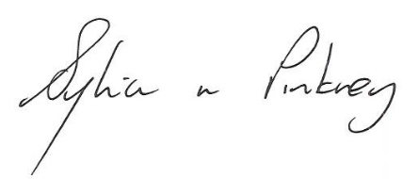
Sylvia Pinkney
Assistant Director
(Regulatory Services)

The Licensing Section
Public Protection Division
Hartlepool Borough Council
Civic Centre
Victoria Road
Hartlepool
TS24 8AY

