

THE LICENSING ACT 2003

PREMISES LICENCE SUMMARY (PART B)

Premises licence number | HART/551

Premises details
Postal address of premises or, if none, ordnance survey map reference, or description
Crafty Monkey Brewing Co.
Benknowle Farm
Elwick

Post Town Hartlepool | Post Code TS27 3HF

Telephone number 07875090305/07572828065

Where the licence is time limited the dates

N/A

Licensable activities authorised by the licence. Any entertainment authorised by this licence is limited to indoors only, unless stated otherwise.

Supply of Alcohol

This licence does not authorise the provision of adult entertainment.

The times the licence authorises the carrying out of licensable activities

Monday – Sunday 09:00 – 17:00

The opening hours of the premises

Off Sales Only – Not open to the general public

Where the licence authorises supplies of alcohol whether these are on and / or off supplies

Off Sales Only

Name, (registered) address of holder of premises licence

Crafty Monkey Brewing Co.
Benknowle Farm
Elwick
Hartlepool
TS27 3HF

Registered number of holder, for example company number, charity number (where applicable)

10981976

Name of designated premises supervisor where the premises licence authorises for the supply of alcohol

Mr Gary Olvanhill

State whether access to the premises by children is restricted or prohibited

Prohibited

Date Licence Granted: 28th August 2019

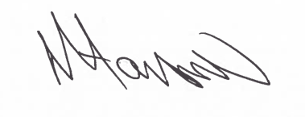
Tony Hanson
Assistant Director
(Environment & Neighbourhood Services)

The Licensing Section
Hartlepool Borough Council
Civic Centre
Victoria Road
Hartlepool
TS24 8AY

