

THE LICENSING ACT 2003

PREMISES LICENCE SUMMARY (PART B)

Premises licence number | HART/546

Premises details
Postal address of premises or, if none, ordnance survey map reference, or description
33 The Green
Elwick

Post Town Hartlepool | Post Code TS27 3EF

Telephone number

Where the licence is time limited the dates

N/A

Licensable activities authorised by the licence. Any entertainment authorised by this licence is limited to indoors only, unless stated otherwise.

Supply of Alcohol

This licence does not authorise the provision of adult entertainment.

The times the licence authorises the carrying out of licensable activities

Monday – Sunday 12:00 – 21:00

The opening hours of the premises

Monday – Sunday 07:00 – 21:00

Where the licence authorises supplies of alcohol whether these are on and / or off supplies

On and Off Sales

Name, (registered) address of holder of premises licence

Mr John Derek Cooper
Lane House
The Ghyll
Elwick
TS27 3DS

Registered number of holder, for example company number, charity number (where applicable)

N/A

Name of designated premises supervisor where the premises licence authorises for the supply of alcohol

Mr John Derek Cooper

State whether access to the premises by children is restricted or prohibited

Not Restricted

Date Licence Granted: 8th February 2019

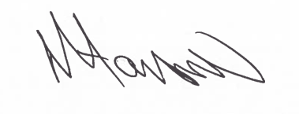
Assistant Director
(Environment & Neighbourhood Services)

The Licensing Section
Hartlepool Borough Council
Civic Centre
Victoria Road
Hartlepool
TS24 8AY

