THE LICENSING ACT 2003

PREMISES LICENCE SUMMARY (PART B)

Premises licence number | HART/PS/146

Premises details

Postal address of premises or, if none, ordnance survey map reference, or description

The Douglas Hotel
2 Grange Road

Post Town Hartlepool | Post code TS26 8JA

Telephone number 01429 272038

Where the licence is time limited the dates

N/A

Licensable activities authorised by the licence

Alcohol Sales - On and Off sales
Recorded Music
Late Night Refreshment

The times the licence authorises the carrying out of licensable activities

Alcohol Sales, Recorded Music & Late Night Refreshment

Monday – Saturday 11:00 – 00:00
Sunday 12:00 – 23:30

Christmas Day 12:00 – 23:30
Good Friday 12:00 – 23:30

The opening hours of the premises

At the discretion of the licensee

Where the licence authorises supplies of alcohol whether these are on and / or off supplies
On and Off sales

Name, (registered) address of holder of premises licence

Mr Raqeeb Ramzan
2 Grange Road
Hartlepool
TS26 8JA

Registered number of holder, for example company number, charity number (where applicable)
N/A

Name of designated premises supervisor where the premises licence authorises for the supply of alcohol

Izhran Hussain

State whether access to the premises by children is restricted or prohibited

Unrestricted

Date licence granted: 4th April 2019

Licence Authorised by:
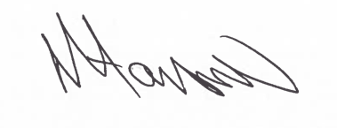

Tony Hanson, Assistant Director
(Environmental and Neighbourhood Services)

The Licensing Section
Public Protection Division
Hartlepool Borough Council
Civic Centre
Victoria Road
Hartlepool
TS24 7BT

