

THE LICENSING ACT 2003

PREMISES LICENCE SUMMARY (PART B)

Premises licence number | HART/PS/554

Premises details
Postal address of premises or, if none, ordnance survey map reference, or description
Wilton Grange
187 Grange Road

Post Town Hartlepool | Post Code TS26 8LX

Telephone number 07915 772200

Where the licence is time limited the dates

N/A

Licensable activities authorised by the licence. Any entertainment authorised by this licence is limited to indoors only, unless stated otherwise.

Supply of Alcohol

This licence does not authorise the provision of adult entertainment.

The times the licence authorises the carrying out of licensable activities

Supply of Alcohol

Monday – Sunday 0700 – 2300 hours

The opening hours of the premises

Monday – Sunday 24 hours

Where the licence authorises supplies of alcohol whether these are on and / or off supplies

On sales only

Name, (registered) address of holder of premises licence

Wilton Grange Hotel Ltd
187 Grange Road
Hartlepool
TS26 8LX

Registered number of holder, for example company number, charity number (where applicable)

11986870

Name of designated premises supervisor where the premises licence authorises for the supply of alcohol

State whether access to the premises by children is restricted or prohibited

Restricted

Date Licence Granted: 5th December 2019

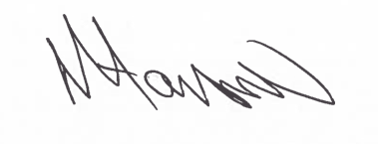
Tony Hanson
Assistant Director
(Environment & Neighbourhood Services)

The Licensing Section
Hartlepool Borough Council
Civic Centre
Victoria Road
Hartlepool
TS24 8AY

