THE LICENSING ACT 2003

PREMISES LICENCE SUMMARY (PART B)

Premises licence number | HART/PS/097

Premises details

Postal address of premises or, if none, ordnance survey map reference, or description

Bull & Dog
High Street
Greatham

Post Town Hartlepool | Post code TS25 2EN

Telephone number 01429 872655

Where the licence is time limited the dates

N/A

Licensable activities authorised by the licence

Alcohol Sales - On and Off Supplies
Recorded Music

The times the licence authorises the carrying out of licensable activities

Alcohol Sales

Monday – Saturday 10:00 – 23:00
Sunday 10:00 – 22:30

Recorded Music
Monday – Sunday 00:01 – 00:00

The opening hours of the premises

Monday – Saturday 10:00 – 23:30
Sunday 10:00 – 23:00

Where the licence authorises supplies of alcohol whether these are on and / or off supplies

On and Off Supplies

Name, (registered) address of holder of premises licence

Miss Jayne Gallagher
14 Shelley Grove
Hartlepool
TS25 5PH

Registered number of holder, for example company number, charity number (where applicable)

N/A

Name of designated premises supervisor where the premises licence authorises for the supply of alcohol

Miss Jayne Gallagher

State whether access to the premises by children is restricted or prohibited

Restricted

Date licence granted: 15th February 2018

Licence Authorised by:

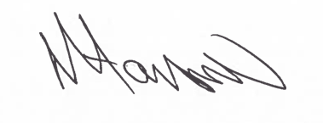
Assistant Director
(Environment & Neighbourhood Services)

The Licensing Section
Public Protection
Hartlepool Borough Council
Civic Centre
Victoria Road
Hartlepool
TS24 8AY

