

THE LICENSING ACT 2003

PREMISES LICENCE SUMMARY (PART B)

Premises licence number | HART/PS/535

Premises details
Postal address of premises or, if none, ordnance survey map reference, or description
Hartlepool Waterfront
The Highlight

Post Town Hartlepool | Post Code TS24 0YA

Telephone number

Where the licence is time limited the dates

N/A

Licensable activities authorised by the licence. Any entertainment authorised by this licence is limited to indoors only, unless stated otherwise.

1. Supply of Alcohol 2. Plays
3. Films 4. Live Music
5. Recorded Music 6. Performance of Dance
7. Anything similar to 4, 5 and 6

This licence does not authorise the provision of adult entertainment.

The times the licence authorises the carrying out of licensable activities

1. Supply of Alcohol 2. Plays
3. Films 4. Live Music
5. Recorded Music 6. Performance of Dance
7. Anything similar to 4, 5 and 6

Monday – Sunday 09:00 – 23:00

The opening hours of the premises

Monday – Sunday 09:00 – 23:00

Where the licence authorises supplies of alcohol whether these are on and / or off supplies

On and Off Sales

Name, (registered) address of holder of premises licence

Hartlepool Borough Council
Sir William Gray House
Clarence Road
Hartlepool
TS24 8BT

Registered number of holder, for example company number, charity number (where applicable)

N/A

Name of designated premises supervisor where the premises licence authorises for the supply of alcohol

Aaron Joseph David Bowman

State whether access to the premises by children is restricted or prohibited

Unrestricted

Date Licence Granted: 22nd June 2021

Licence Authorised by:

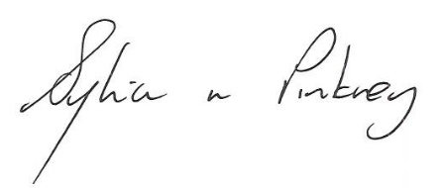
Sylvia Pinkney
Assistant Director
(Regulatory Services)

The Licensing Section
Public Protection Division
Hartlepool Borough Council
Civic Centre
Victoria Road
Hartlepool
TS24 8AY

