THE LICENSING ACT 2003

PREMISES LICENCE SUMMARY (PART B)

Premises licence number | HART/PS/569

Premises details
Postal address of premises or, if none, ordnance survey map reference, or description
Prashan Express
81 King Oswy Drive

Post Town Hartlepool | Post Code TS24 9PF

Telephone number 07450822196

Where the licence is time limited the dates

N/A

Licensable activities authorised by the licence. Any entertainment authorised by this licence is limited to indoors only, unless stated otherwise.

Alcohol Sales (Off Sales)

This licence does not authorise the provision of adult entertainment.

The times the licence authorises the carrying out of licensable activities

Alcohol (Off Sales) Monday – Sunday 08:00 – 22:00

The opening hours of the premises

Monday – Sunday 05:30 – 22:00

Where the licence authorises supplies of alcohol whether these are on and / or off supplies

Off Sales Only

Name, (registered) address of holder of premises licence

Piratheepa Berkman
Flat above 81 King Oswy Drive
Hartlepool
TS24 9FP

Registered number of holder, for example company number, charity number (where applicable)

N/A

Name of designated premises supervisor where the premises licence authorises for the supply of alcohol

Piratheepa Berkman

State whether access to the premises by children is restricted or prohibited

N/A

Date Licence Granted: 8th April 2021

Licence Authorised by:

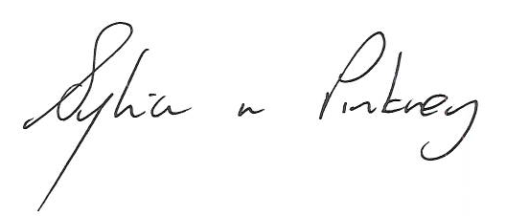

Sylvia Pinkney, Assistant Director
(Regulatory Services)

he Licensing Section
Hartlepool Borough Council
Civic Centre
Victoria Road
Hartlepool
TS24 8AY

