THE LICENSING ACT 2003

PREMISES LICENCE SUMMARY (PART B)

Premises licence number | HART/PS/262

Premises details

Postal address of premises or, if none, ordnance survey map reference, or description

McDonalds Restaurant
Marina Way

Post Town Hartlepool | Post code TS24 0XR

Telephone number 01429 890826

Where the licence is time limited the dates

N/A

Licensable activities authorised by the licence

Recorded Music (Dining Area Only)
Late Night Refreshment

The times the licence authorises the carrying out of licensable activities

Monday – Sunday 00:00 – 00:00

The opening hours of the premises

Monday – Sunday 00:00 – 00:00

Where the licence authorises supplies of alcohol whether these are on and / or off supplies

N/A

Name, (registered) address of holder of premises licence

Nucleus (G.B.) Ltd
Fusion House
1 Plains Road
Sunderland
Tyne & Wear
SR3 1SL

Registered number of holder, for example company number, charity number (where applicable)

04546362

Name of designated premises supervisor where the premises licence authorises for the supply of alcohol
N/A

State whether access to the premises by children is restricted or prohibited

Unrestricted

Date licence granted: 16th January 2020

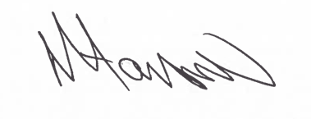

Tony Hanson
Assistant Director
(Environment & Neighbourhood Services)

The Licensing Section
Hartlepool Borough Council
Civic Centre
Victoria Road
Hartlepool
TS24 8AY

