THE LICENSING ACT 2003

PREMISES LICENCE SUMMARY (PART B)

Premises licence number | HART/PS/282

Premises details

Postal address of premises or, if none, ordnance survey map reference, or description

NMRN Hartlepool
Jackson’s Dock
Maritime Avenue

Post Town Hartlepool | Post code TS24 0XZ

Telephone number 01429 860077

Where the licence is time limited the dates

N/A

Licensable activities authorised by the licence

1. Alcohol Sales - On and Off sales

2. Plays

3. Films

4. Indoor Sporting Events

5. Live Music

6. Recorded Music

7. Performance of Dance

8. Anything similar to 5,6 & 7 above

9. Provision of facilities for making music

10. Provision of facilities for dancing
11. Provision of facilities for entertainment similar to 9 & 10 above
12. Late Night Refreshment

The times the licence authorises the carrying out of licensable activities

1. Alcohol Sales - On and Off sales Mon – Sun 1000 – 0000

2. Plays Mon – Sun 1000 – 0000

3. Films Mon – Sun 1000 – 0000

4. Indoor Sporting Events Mon – Sun 1000 – 0000

5. Live Music Mon – Sun 1000 – 0000

6. Recorded Music Mon – Sun 1000 – 0000

7. Performance of Dance Mon – Sun 1000 – 2200

8. Anything similar to 5,6 & 7 above Mon – Sun 1000 – 0000

9. Provision of facilities for making music Mon – Sun 1000 – 0000

10. Provision of facilities for dancing Mon – Sun 1000 – 0000
11. Provision of facilities for entertainment
similar to 9 & 10 above Mon – Sun 1000 – 0000
12. Late Night Refreshment Mon – Sun 1000 – 0000

The opening hours of the premises

Monday – Sunday 1000 – 0000

Where the licence authorises supplies of alcohol whether these are on and / or off supplies

On and Off supplies

Name, (registered) address of holder of premises licence

The National Museum of the Royal Navy
The Naval Base (PP66)
Portsmouth
Hants
PO1 3NH

Registered number of holder, for example company number, charity number (where applicable)

N/A

Name of designated premises supervisor where the premises licence authorises for the supply of alcohol
Roslyn Margaret Adamson

State whether access to the premises by children is restricted or prohibited

Unrestricted

Date licence granted: 14th October 2020

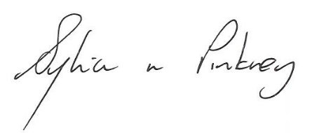
Sylvia Pinkney
Assistant Director (Regulatory Services)

The Licensing Section
Public Protection and Housing
Hartlepool Borough Council
Civic Centre
Victoria Road
Hartlepool
TS24 8AY

