THE LICENSING ACT 2003

PREMISES LICENCE SUMMARY (PART B)

Premises licence number | HART/PS/076

Premises details

Postal address of premises or, if none, ordnance survey map reference, or description

Portofino
The Historic Quay

Post Town Hartlepool | Post code TS24 0XZ

Telephone number

Where the licence is time limited the dates

N/A

Licensable activities authorised by the licence. Any entertainment authorised by this licence is limited to indoors only, unless stated otherwise.

Alcohol Sales (On & Off Licence)

Provision of Late Night Refreshment

The times the licence authorises the carrying out of licensable activities

Alcohol Sales

Monday – Sunday 1100 – 0000

Provision of Late Night Refreshment

Monday – Sunday 23:00 – 00:00

The opening hours of the premises

Monday – Sunday 10:00 – 00:00

Where the licence authorises supplies of alcohol whether these are on and / or off supplies

On & Off Sales

Name, (registered) address of holder of premises licence

Mr Noel Stamp
30 Arncliffe Gardens
Hartlepool
TS26 9JG

Registered number of holder, for example company number, charity number (where applicable)

N/A

Name of designated premises supervisor where the premises licence authorises for the supply of alcohol

Elaine Lee

State whether access to the premises by children is restricted or prohibited

Restricted

Date Licence Granted: 21st June 2022

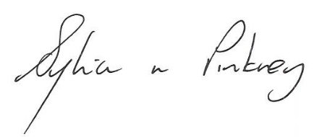

Sylvia Pinkney,
Assistant Director
(Regulatory Services)

The Licensing Section
Public Protection Division
Hartlepool Borough Council
Civic Centre
Victoria Road
Hartlepool
TS24 8AY

