THE LICENSING ACT 2003

PREMISES LICENCE SUMMARY (PART B)

Premises licence number | HART/PS/380

Premises details
Postal address of premises or, if none, ordnance survey map reference, or description

Rift House Community Centre
Masefield Road

Post Town Hartlepool | Post Code TS25 4JY

Telephone number 01429 284453

Where the licence is time limited the dates
N/A

Licensable activities authorised by the licence. Any entertainment authorised by this licence is limited to indoors only, unless stated otherwise.

1. Plays 6. Anything Similar to 3, 4 or 5 above
2. Films 7. Provision of Facilities for Making Music
3. Live Music 8. Provision of Facilities for Dancing
4. Recorded Music 9. Entertainment Similar to 7or 8 above
5. Performance of Dance

The times the licence authorises the carrying out of licensable activities

Monday – Sunday 09:00 – 22:00

The opening hours of the premises

Monday – Sunday 09:00 – 22:00

Where the licence authorises supplies of alcohol whether these are on and / or off supplies

N/A

Name, (registered) address of holder of premises licence

Hartlepool Borough Council
Child & Adults Services
Civic Centre
Victoria Road
Hartlepool
TS24 8AY

Registered number of holder, for example company number, charity number (where applicable)

N/A

Name of designated premises supervisor where the premises licence authorises for the supply of alcohol

State whether access to the premises by children is restricted or prohibited

Unrestricted

Date Licence Granted: 15th November 2018

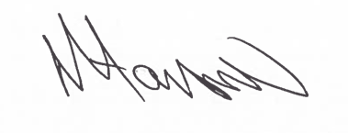
Assistant Director
(Environment & Neighbourhood Services)

The Licensing Section
Public Protection Division
Hartlepool Borough Council
Civic Centre, Victoria Road
Hartlepool
TS24 8AY

