

THE LICENSING ACT 2003

PREMISES LICENCE SUMMARY (PART B)

Premises licence number | HART/PS/432

Premises details
Postal address of premises or, if none, ordnance survey map reference, or description
Home Bargains
Unit 35-38a
Middleton Grange Shopping Centre

Post Town Hartlepool | Post Code TS24 7RZ

Telephone number

Where the licence is time limited the dates
N/A

Licensable activities authorised by the licence. Any entertainment authorised by this licence is limited to indoors only, unless stated otherwise.

Supply of Alcohol

This licence does not authorise the provision of adult entertainment.

The times the licence authorises the carrying out of licensable activities

Monday to Sunday 08:00 – 22:00

The opening hours of the premises

Monday to Sunday 08:00 -22:00

Where the licence authorises supplies of alcohol whether these are on and / or off supplies

N/A

Name, (registered) address of holder of premises licence

T.J. Morris Limited t/a Home Bargains
Axis Business Park
Portal Way
Gillmoss
Liverpool
L11 0JA

Registered number of holder, for example company number, charity number (where applicable)

1505036

Name of designated premises supervisor where the premises licence authorises for the supply of alcohol

Karen Thomas

State whether access to the premises by children is restricted or prohibited

Unrestricted

Date Licence Granted: 25th February 2021

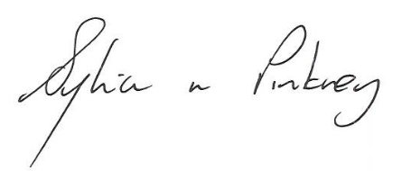
Sylvia Pinkney
Assistant Director
(Regulatory Services)

The Licensing Section
Public Protection Division
Hartlepool Borough Council
Civic Centre
Victoria Road
Hartlepool
TS24 8AY

