

THE LICENSING ACT 2003

PREMISES LICENCE SUMMARY (PART B)

Premises licence number | HART/PS/472

Premises details
Postal address of premises or, if none, ordnance survey map reference, or description
T J Hughes
Unit 195 Middleton Grange Shopping Centre

Post Town Hartlepool | Post Code TS24 7RZ

Telephone number 01429862657

Where the licence is time limited the dates

N/A

Licensable activities authorised by the licence. Any entertainment authorised by this licence is limited to indoors only, unless stated otherwise.

Supply of Alcohol

This licence does not authorise the provision of adult entertainment.

The times the licence authorises the carrying out of licensable activities

January – October
Monday – Saturday 0900 – 1730
Sundays 1000 – 1600

November – December
Monday - Sunday 0800 – 2100

The opening hours of the premises

January – October
Monday – Saturday 0900 – 1730
Sundays 1000 – 1600

November – December
Monday - Sunday 0800 – 2100

Where the licence authorises supplies of alcohol whether these are on and / or off supplies

Off Sales

Name, (registered) address of holder of premises licence

LHR Holding Ltd
Building 2000
1st Floor, Vortex Court
Enterprise Way
Liverpool
L13 1FB

Registered number of holder, for example company number, charity number (where applicable)

11858129

Name of designated premises supervisor where the premises licence authorises for the supply of alcohol

Matthew Jonathan Philpot

State whether access to the premises by children is restricted or prohibited

Unrestricted

Date Licence Granted: 5th March 2020

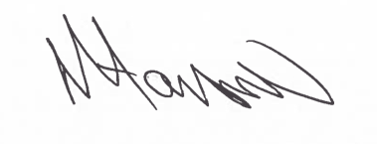

Tony Hanson
Assistant Director
(Environment & Neighbourhood Services)

The Licensing Section
Hartlepool Borough Council
Civic Centre
Victoria Road
Hartlepool
TS24 8AY

