

THE LICENSING ACT 2003

PREMISES LICENCE SUMMARY (PART B)

Premises licence number | HART/553

Premises details
Postal address of premises or, if none, ordnance survey map reference, or description
Savers
Unit 30-31 Middleton Grange Shopping Centre

Post Town Hartlepool | Post Code TS24 8AY

Telephone number

Where the licence is time limited the dates

N/A

Licensable activities authorised by the licence. Any entertainment authorised by this licence is limited to indoors only, unless stated otherwise.

Supply of Alcohol

This licence does not authorise the provision of adult entertainment.

The times the licence authorises the carrying out of licensable activities

08:00 - 18:30 Monday – Saturday
10:00 - 17:00 Sunday

Monday – Saturday 14th November – 24th December until 20:00

The opening hours of the premises

08:00 - 18:30 Monday – Saturday
10:00 - 17:00 Sunday

Where the licence authorises supplies of alcohol whether these are on and / or off supplies

Off sales only

Name, (registered) address of holder of premises licence

Savers Health & Beauty Ltd
Hutchinson House
5 Hester Road
Battersea
London
SW11 4AN

Registered number of holder, for example company number, charity number (where applicable)

2202838

Name of designated premises supervisor where the premises licence authorises for the supply of alcohol

Colleen Murphy

State whether access to the premises by children is restricted or prohibited

Unrestricted

Date Licence Granted: 6th May 2022

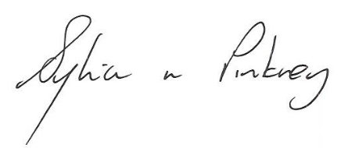
Sylvia Pinkney
Assistant Director
(Regulatory Services)

The Licensing Section
Public Protection Division
Hartlepool Borough Council
Civic Centre
Victoria Road
Hartlepool
TS24 8AY

