

THE LICENSING ACT 2003

PREMISES LICENCE SUMMARY (PART B)

Premises licence number | HART/PS/477

Premises details
Postal address of premises or, if none, ordnance survey map reference, or description
Spar
Unit 1 The Mowbray
Mowbray Road

Post Town Hartlepool | Post Code TS25 2ND

Telephone number 01429 872912

Where the licence is time limited the dates

N/A

Licensable activities authorised by the licence. Any entertainment authorised by this licence is limited to indoors only, unless stated otherwise.

Supply of Alcohol

This licence does not authorise the provision of adult entertainment.

The times the licence authorises the carrying out of licensable activities

Monday to Sunday 09:00 – 22:00

The opening hours of the premises

Monday to Sunday 07:00 – 22:00

Where the licence authorises supplies of alcohol whether these are on and / or off supplies

Off Sales

Name, (registered) address of holder of premises licence

Meehu Ltd
44 Station Road
Redcar
TS10 1AG

Registered number of holder, for example company number, charity number (where applicable)

09008783

Name of designated premises supervisor where the premises licence authorises for the supply of alcohol

Lorraine Angela Baines

State whether access to the premises by children is restricted or prohibited

Unrestricted

Date Licence Granted: 9th October 2017

Licence Authorised by:

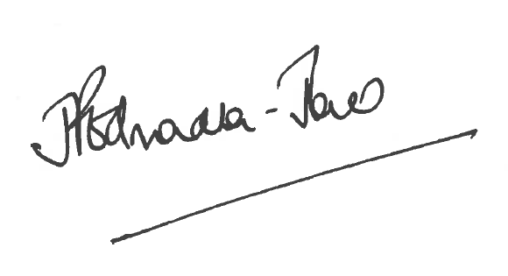
Director of Public Health

The Licensing Section
Hartlepool Borough Council
Civic Centre
Victoria Road
Hartlepool
TS24 8AY

