

THE LICENSING ACT 2003

PREMISES LICENCE SUMMARY (PART B)

Premises licence number | HART/PS/458

Premises details
Postal address of premises or, if none, ordnance survey map reference, or description

Unit 3, The Mowbray
Mowbray Road

Post Town Hartlepool | Post Code TS25 2ND

Telephone number

Where the licence is time limited the dates

N/A

Licensable activities authorised by the licence. Any entertainment authorised by this licence is limited to indoors only, unless stated otherwise.

- Supply of Alcohol
- Recorded Music

This licence does not authorise the provision of adult entertainment.

The times the licence authorises the carrying out of licensable activities

Monday to Sunday – 12:00 – 23:30

The opening hours of the premises

Monday to Sunday – 12:00 – 24:00

Where the licence authorises supplies of alcohol whether these are on and / or off supplies

On Sales Only

Name, (registered) address of holder of premises licence

Mrs Nicola Morrison
141 Central avenue
Billingham
TS23 1LR

Registered number of holder, for example company number, charity number (where applicable)

N/A

Name of designated premises supervisor where the premises licence authorises for the supply of alcohol

Mrs Nicola Morrison

State whether access to the premises by children is restricted or prohibited

Restricted

Date Licence Granted: 26th June 2020

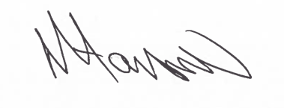
Tony Hanson
Assistant Director
(Environment & Neighbourhood Services)

The Licensing Section
Hartlepool Borough Council
Civic Centre
Victoria Road
Hartlepool
TS24 8AY

