

THE LICENSING ACT 2003

PREMISES LICENCE SUMMARY (PART B)

Premises licence number | HART/PS/442

Premises details
Postal address of premises or, if none, ordnance survey map reference, or description
36 Mulgrave Road

Post Town Hartlepool | Post Code TS26 8EB

Telephone number

Where the licence is time limited the dates
N/A

Licensable activities authorised by the licence. Any entertainment authorised by this licence is limited to indoors only, unless stated otherwise.

Supply of Alcohol

This licence does not authorise the provision of adult entertainment.

The times the licence authorises the carrying out of licensable activities

Monday to Saturday - 0900 – 2230
Sunday 1000 - 2230

The opening hours of the premises

Monday to Sunday - 0600 – 2300
Sunday 0700 - 2230

Where the licence authorises supplies of alcohol whether these are on and / or off supplies

Off Sales Only

Name, (registered) address of holder of premises licence

Mr Pasupathy Uthayasekaran
1 Wilson Street
Hartlepool
TS26 8JX

Registered number of holder, for example company number, charity number (where applicable)

N/A

Name of designated premises supervisor where the premises licence authorises for the supply of alcohol

Mr Pasupathy Uthayasekaran

State whether access to the premises by children is restricted or prohibited

Unrestricted

Date Licence Granted: 18th July 2019

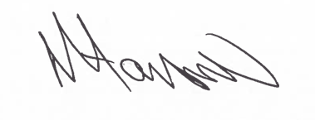

Tony Hanson
Assistant Director
(Environment & Neighbourhood Services)

The Licensing Section
Hartlepool Borough Council
Civic Centre
Victoria Road
Hartlepool
TS24 8AY

