THE LICENSING ACT 2003

PREMISES LICENCE SUMMARY (PART B)

Premises licence number | HART/PS/008

Premises details

Postal address of premises or, if none, ordnance survey map reference, or description

McColls
10 Murray Street

Post Town Hartlepool | Post code TS26 8PE

Telephone number

Where the licence is time limited the dates

N/A

Licensable activities authorised by the licence

Alcohol Sales

Off-Licence

The times the licence authorises the carrying out of licensable activities

Alcohol Sales

Off-Licence Monday – Sunday 0800 – 2300

The opening hours of the premises

At the discretion of the licensee

Where the licence authorises supplies of alcohol whether these are on and / or off supplies

Off-sales

Name, (registered) address of holder of premises licence

Martin McColl Limited
Ground Floor West
One London Road
Brentwood
Essex
CM14 4QW

Registered number of holder, for example company number, charity number (where applicable)

298945

Name of designated premises supervisor where the premises licence authorises for the supply of alcohol

Carlie Ann Greig

State whether access to the premises by children is restricted or prohibited

Unrestricted

Date licence granted: 6th July 2021

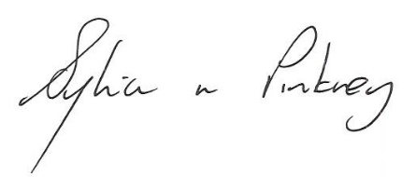
Sylvia Pinkney
Assistant Director
(Regulatory Services)

The Licensing Section
Public Protection Division
Hartlepool Borough Council
Civic Centre
Victoria Road
Hartlepool
TS24 8AY

