

THE LICENSING ACT 2003

PREMISES LICENCE SUMMARY (PART B)

Premises licence number | HART/497

Premises details
Postal address of premises or, if none, ordnance survey map reference, or description
33 Murray Street

Post Town Hartlepool | Post Code TS26 8PQ

Telephone number 07548406741

Where the licence is time limited the dates

N/A

Licensable activities authorised by the licence. Any entertainment authorised by this licence is limited to indoors only, unless stated otherwise.

Supply of Alcohol

This licence does not authorise the provision of adult entertainment.

The times the licence authorises the carrying out of licensable activities

Monday to Sunday 09:00 – 21:00

The opening hours of the premises

Monday to Sunday 09:00 – 22:00

Where the licence authorises supplies of alcohol whether these are on and / or off supplies

Off Sales

Name, (registered) address of holder of premises licence

MWitemberg Ltd
T/A Rodzynek
31-33 Murray Street
Hartlepool
TS26 8PQ

Registered number of holder, for example company number, charity number (where applicable)

12387401

Name of designated premises supervisor where the premises licence authorises for the supply of alcohol

Magdalena Witemberg

State whether access to the premises by children is restricted or prohibited

Unrestricted

Date Licence Granted: 27th February 2020

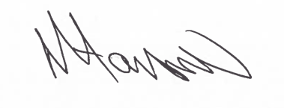

Tony Hanson
Assistant Director
(Environment & Neighbourhood Services)

The Licensing Section
Hartlepool Borough Council
Civic Centre
Victoria Road
Hartlepool
TS24 8AY

