

THE LICENSING ACT 2003

PREMISES LICENCE SUMMARY (PART B)

Premises licence number | HART/PS/473

Premises details
Postal address of premises or, if none, ordnance survey map reference, or description

70 – 72 Murray Street

Post Town Hartlepool | Post Code TS26 8PL

Telephone number

Where the licence is time limited the dates

N/A

Licensable activities authorised by the licence. Any entertainment authorised by this licence is limited to indoors only, unless stated otherwise.

1. Supply of Alcohol
2. Live Music
3. Recorded Music

This licence does not authorise the provision of adult entertainment.

The times the licence authorises the carrying out of licensable activities

1. Supply of Alcohol Monday – Saturday 11:00 – 23:00
Sundays 12:00 – 23:00
2. Live Music Monday – Sunday 20:00 – 23:00
3. Recorded Music Monday – Saturday 11:00 – 23:00
Sundays 12:00 – 23:00

The opening hours of the premises

Monday – Saturday 11:00 – 23:20
Sundays 12:00 – 23:20

Where the licence authorises supplies of alcohol whether these are on and / or off supplies
On and Off Sales

Name, (registered) address of holder of premises licence

Keith Morgan
41 Sandringham Road
Hartlepool
TS26 8PS

Registered number of holder, for example company number, charity number (where applicable)

N/A

Name of designated premises supervisor where the premises licence authorises for the supply of alcohol

Keith Morgan

State whether access to the premises by children is restricted or prohibited

Restricted

Date Licence Granted: 13th October 2020

Licence Authorised by:

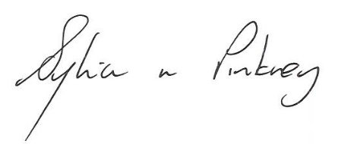

Sylvia Pinkney, Assistant Director
(Regulatory Services)

The Licensing Section
Hartlepool Borough Council
Civic Centre
Victoria Road
Hartlepool
TS24 8AY

