

THE LICENSING ACT 2003

PREMISES LICENCE SUMMARY (PART B)

Premises licence number | HART/549

Premises details
Postal address of premises or, if none, ordnance survey map reference, or description
Grapes Wine Bar
Unit B
1 Navigation Point

Post Town Hartlepool | Post Code TS24 0UH

Telephone number

Where the licence is time limited the dates

N/A

Licensable activities authorised by the licence. Any entertainment authorised by this licence is limited to indoors only, unless stated otherwise.

Recorded Music
Supply of Alcohol

This licence does not authorise the provision of adult entertainment.

The times the licence authorises the carrying out of licensable activities

Monday – Sunday 11:00 – 23:00

The opening hours of the premises

Monday – Sunday 11:00 – 23:30

Where the licence authorises supplies of alcohol whether these are on and / or off supplies

On and Off Supplies

Name, (registered) address of holder of premises licence

Ken Enterprises Ltd
Unit 3
Merchant Evegate Business Park
Ashford
TN25 6SX

Registered number of holder, for example company number, charity number (where applicable)

11923744

Name of designated premises supervisor where the premises licence authorises for the supply of alcohol

Kenneth Eric Muspratt

State whether access to the premises by children is restricted or prohibited

Restricted

Date Licence Granted: 2nd July 2019

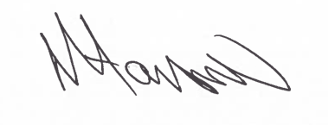
Tony Hanson
Assistant Director
(Environment & Neighbourhood Services)

The Licensing Section
Hartlepool Borough Council
Civic Centre
Victoria Road
Hartlepool
TS24 8AY

