THE LICENSING ACT 2003

PREMISES LICENCE SUMMARY (PART B)

Premises licence number | HART/PS/230

Premises details

Postal address of premises or, if none, ordnance survey map reference, or description

Unit 3
Navigation Point
The Marina

Post Town Hartlepool | Post code TS24 0UH

Telephone number

Where the licence is time limited the dates

N/A

Licensable activities authorised by the licence. Any entertainment authorised by this licence is limited to indoors only, unless stated otherwise.

Alcohol Sales
On and Off Sales

The times the licence authorises the carrying out of licensable activities

Alcohol Sales
On and Off Sales Monday to Saturday 11:00 – 23:00
Sunday 12:00 – 22:30
Christmas Day 12:00 – 15:00 and 19:00 – 22:30
Good Friday 12:00 – 22:30

The opening hours of the premises

At the discretion of the licence holder

Where the licence authorises supplies of alcohol whether these are on and / or off supplies

On and Off Sales

Name, (registered) address of holder of premises licence

So Good Foods Ltd
38 Norton Avenue
Norton
Stockton on Tees
TS20 2JH

Registered number of holder, for example company number, charity number (where applicable)

11969905

Name of designated premises supervisor where the premises licence authorises for the supply of alcohol
Margarita Vinogradova

State whether access to the premises by children is restricted or prohibited

Restricted

Date Licence Granted: 19th November 2019

Licence Authorised by:
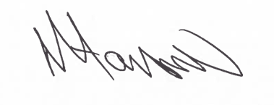

Tony Hanson, Assistant Director
(Environment and Neighbourhood Services)

The Licensing Section
Public Protection
Hartlepool Borough Council
Civic Centre
Victoria Road
Hartlepool
TS24 8AY

