THE LICENSING ACT 2003

PREMISES LICENCE SUMMARY (PART B)

Premises licence number | HART/PS/361

Premises details
Postal address of premises or, if none, ordnance survey map reference, or description

Unit 10 – 12 Navigation Point
Middleton Road

Post Town Hartlepool | Post Code TS24 0UH

Telephone number 01429 864411

Where the licence is time limited the dates
N/A

Licensable activities authorised by the licence. Any entertainment authorised by this licence is limited to indoors only, unless stated otherwise.

1 | Supply of alcohol
2 | Recorded Music
3 | Live Music
4 | Provision of Late Night Refreshment (Indoors and Outdoors)

The times the licence authorises the carrying out of licensable activities

1 | Supply of alcohol | Monday to Sunday | 1030 - 2330
2 | Recorded Music | Monday to Saturday | 0930 – 2330
 |  | Sunday | 0930 – 2300
3 | Live Music | Monday to Sunday | 1930 - 2230
4 | Late Night Refreshment | Monday to Sunday | 2300 - 2330

The opening hours of the premises

Monday to Sunday 0930 - 2400

Where the licence authorises supplies of alcohol whether these are on and / or off supplies

On and off supplies

Name, (registered) address of holder of premises licence

Black Olive Hartlepool Limited
178 York Road
Hartlepool
TS26 9EA

Registered number of holder, for example company number, charity number (where applicable)

10430771

Name of designated premises supervisor where the premises licence authorises for the supply of alcohol

Laura Tarran

State whether access to the premises by children is restricted or prohibited

Restricted

Date Licence Granted: 27th September 2019

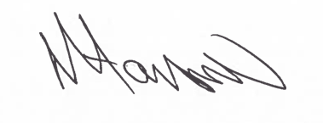
Tony Hanson
Assistant Director
(Environment & Neighbourhood Services)

The Licensing Section
Public Protection Division
Hartlepool Borough Council
Civic Centre,
Victoria Road
Hartlepool
TS24 8AY

